Scaling:

We prefer horizontal scaling over vertical scaling

Single instance- Single server

If sticky session are there means customer are coming to same server for request as per requirement, then vertical scaling is implemented.--> For Horizontal scaling—Scale out—Enable Auto Scaling

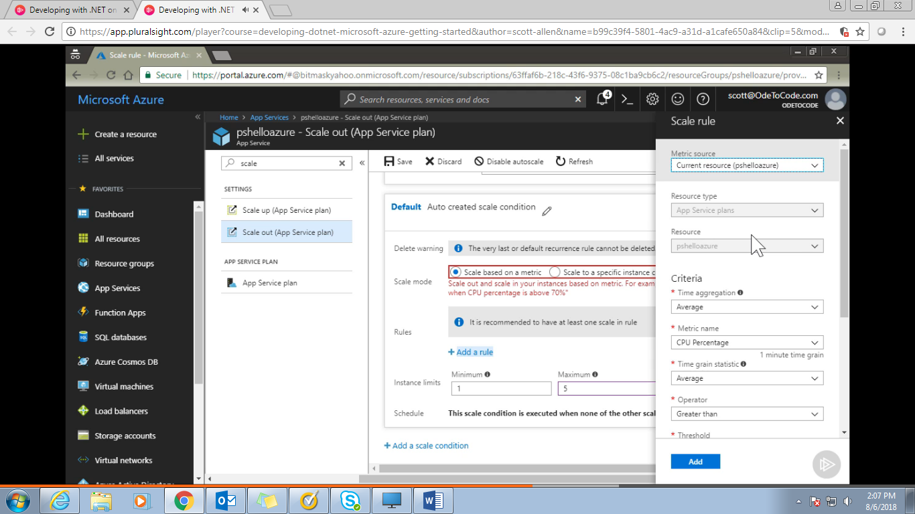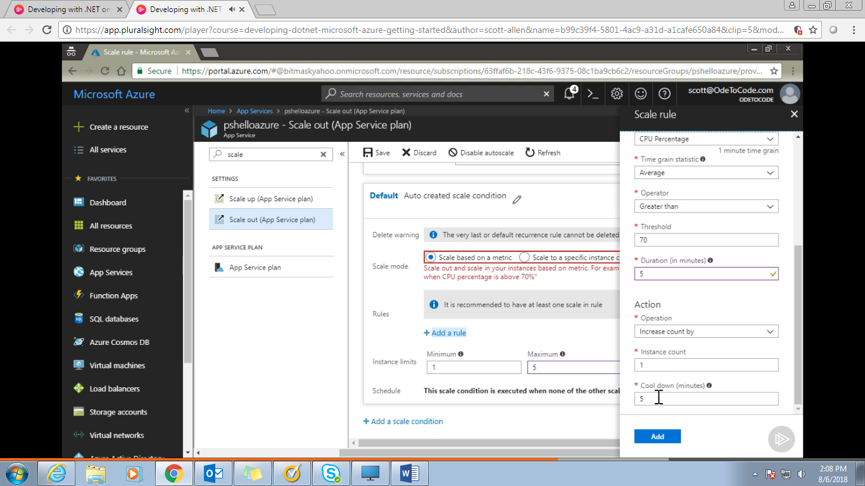

Cool Down Time(=5 minutes): Wait for at least 5 min on specified condition and if still CPU consumption is more than 5 minutes then create a new instance.

Apart from default scale condition (which runs if no other scale condition matches) we can also add additional scale condition based on our requirement which may be repeat on weekends or some specific time when our app service is supposed to have more no of request.

**Application Insight:**

Diagnostic Logs:

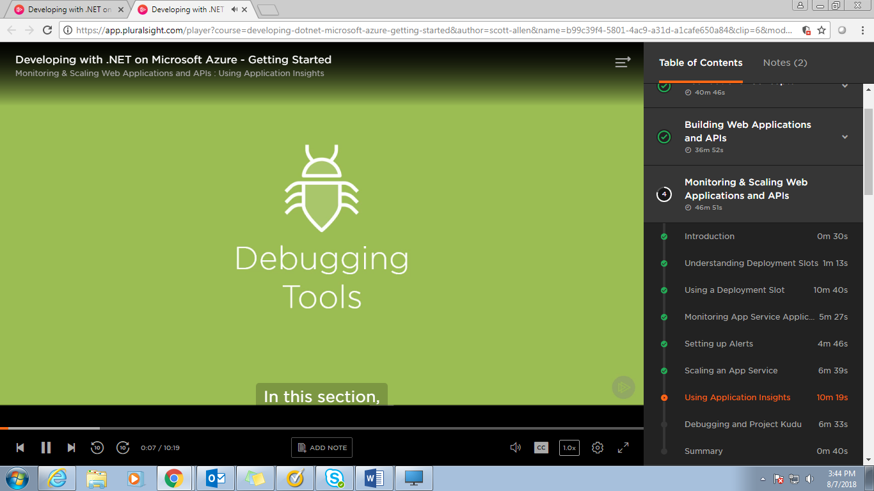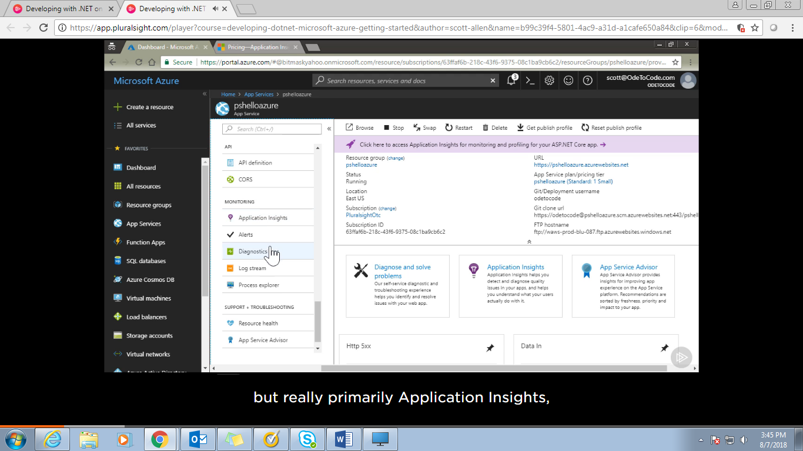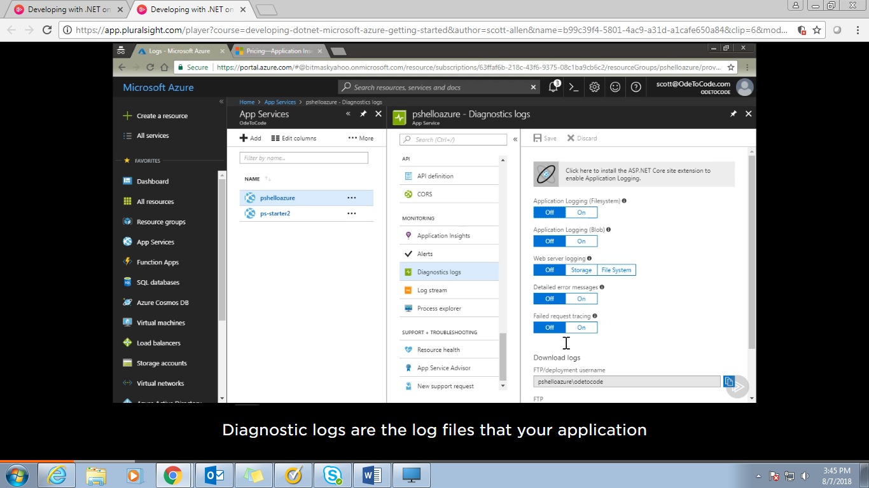

We can log various things here either on FTP or on blob.

Application Insight: capture and store telemetry data of App server

Telemetry data includes information about every request when did it start? When did it stop?

How long did it take? How many database query did it issue? How slow or fast were those queries?

When there is an exception I can get full stack trace? Application Insight isn’t tied to windows or .Net.

There are SDK available for other programming language. I can store information about java script running on my client browser or information from a desktop application.

1st u need to create an application Insight resource. It’s a dedicated resource and not a free resource.

2nd we have to instrument our App service. We can do this through visual studio.

One Application Insight resource is used for multiple applications

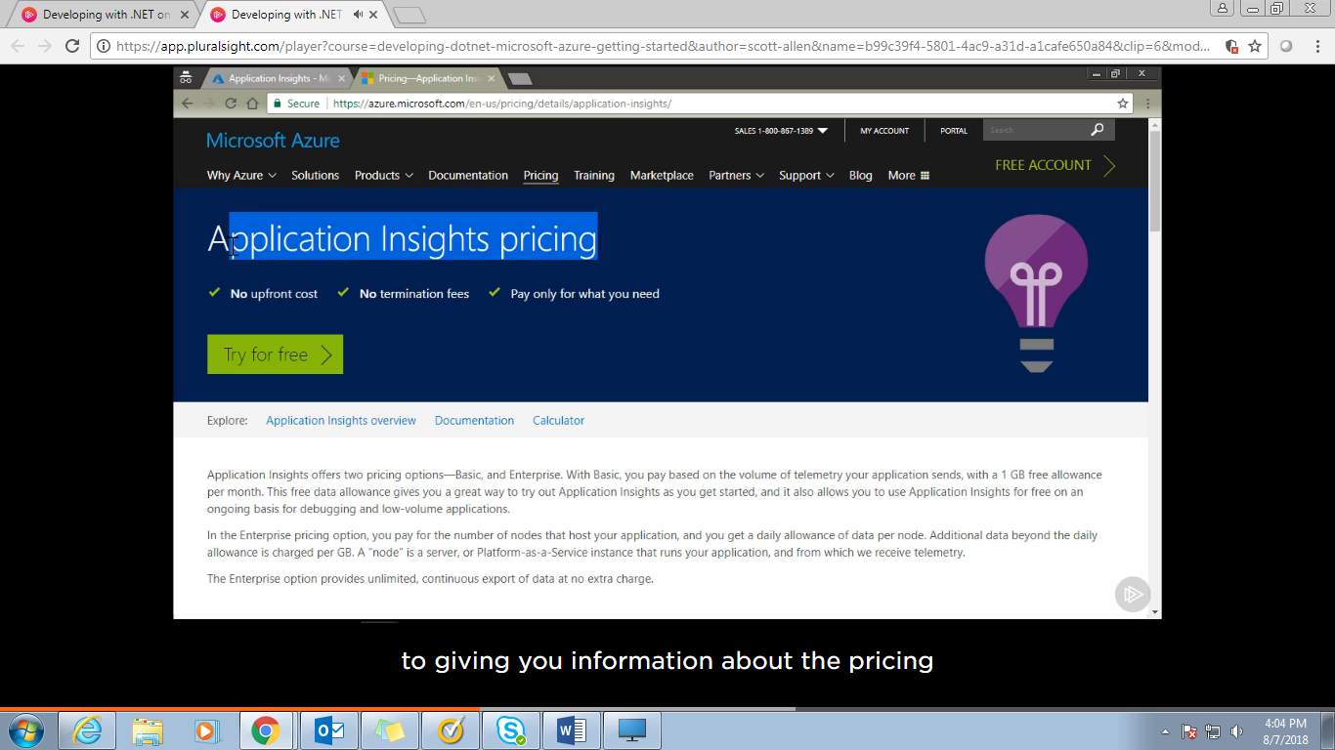

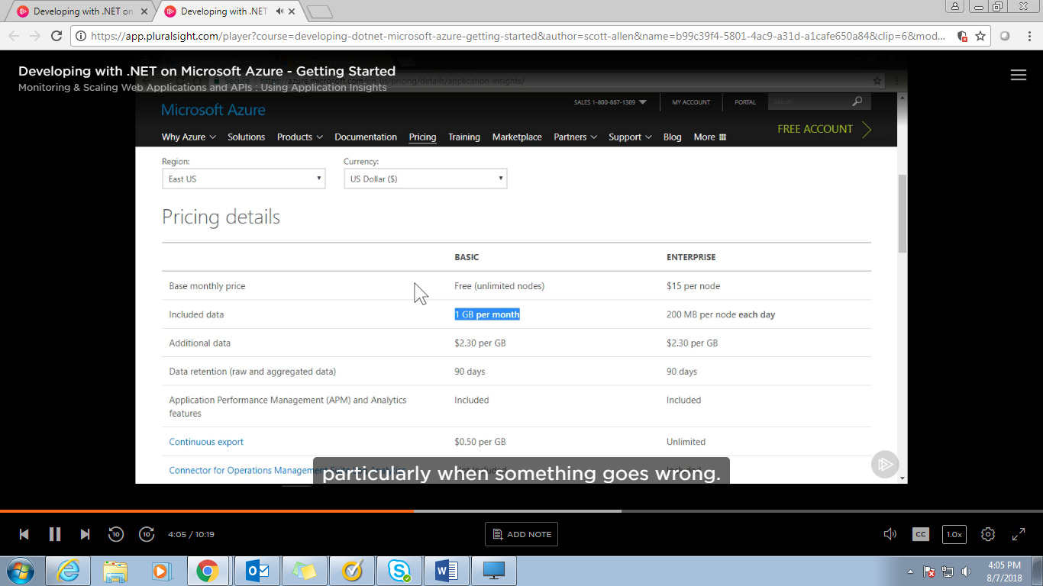

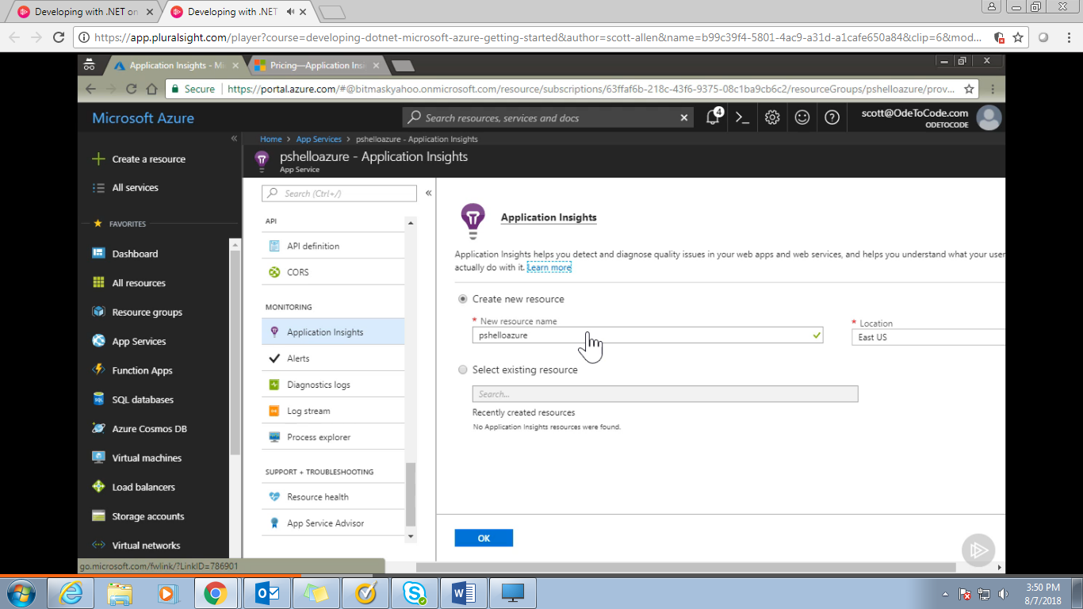

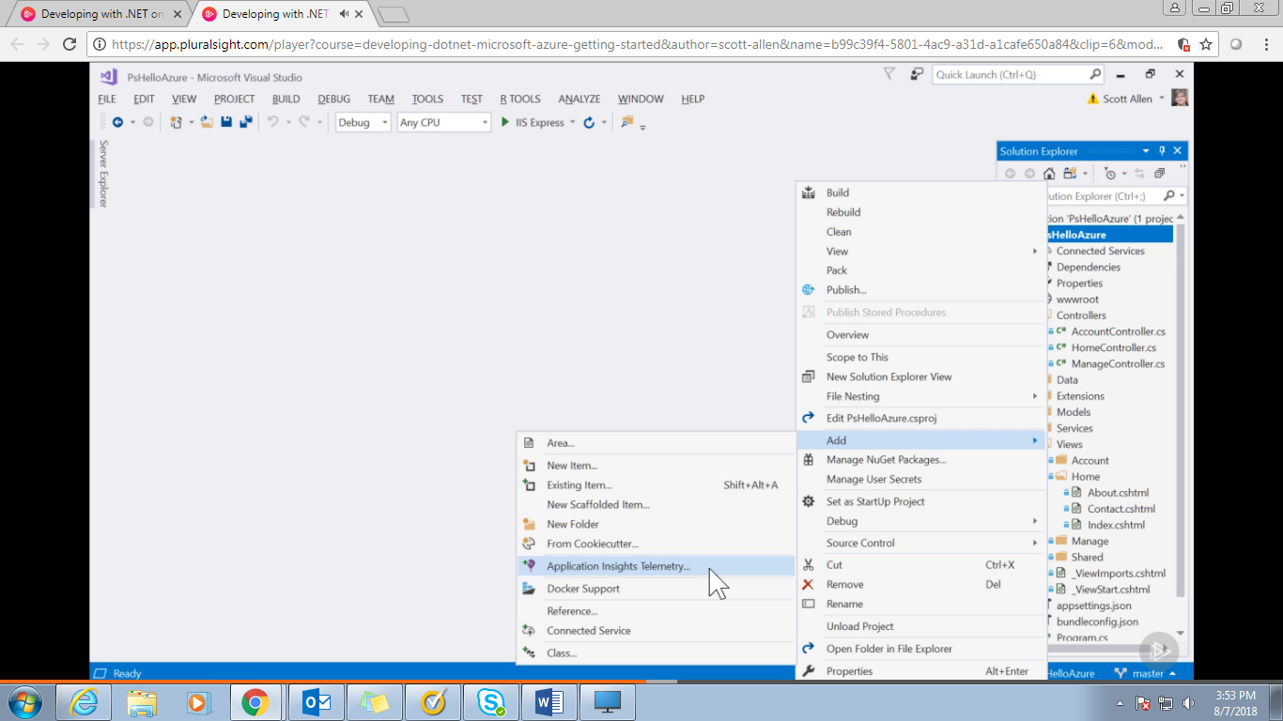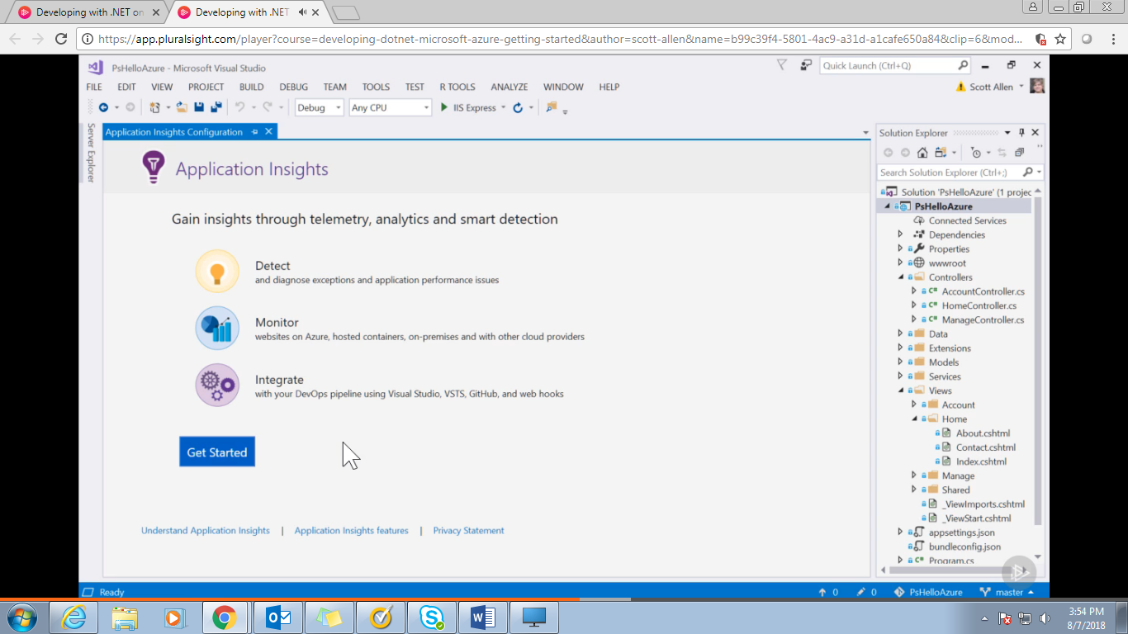

Install some nudget package and manage some configuration changes.

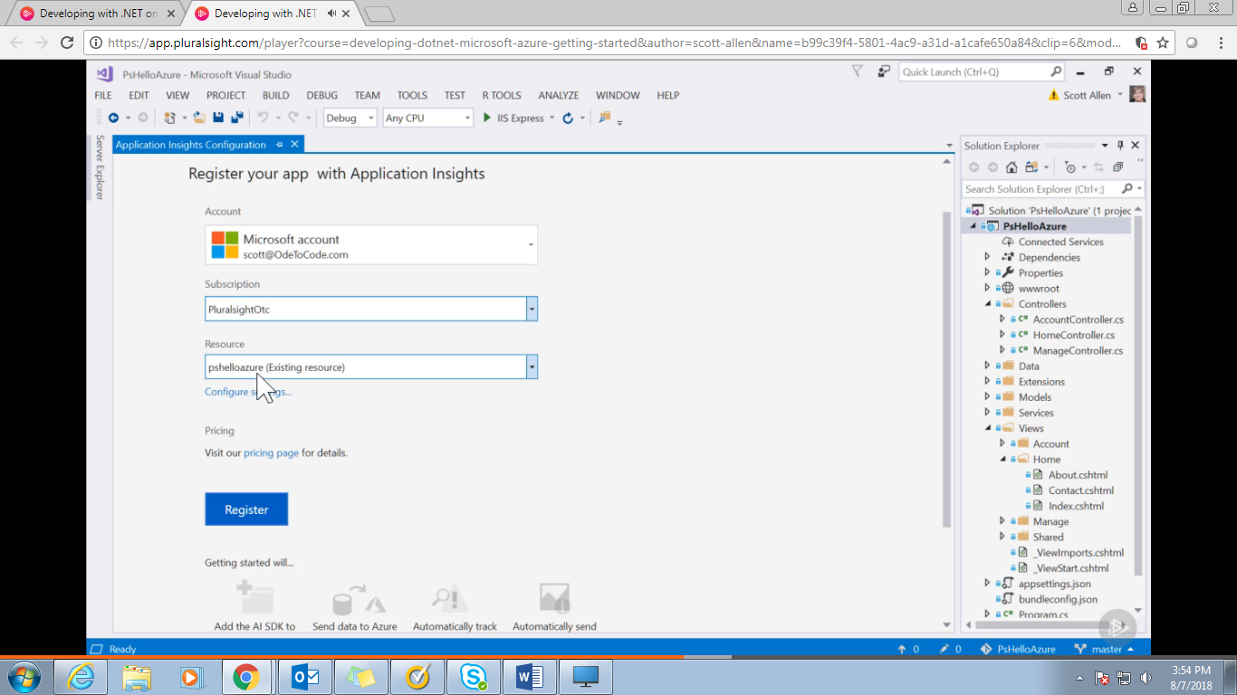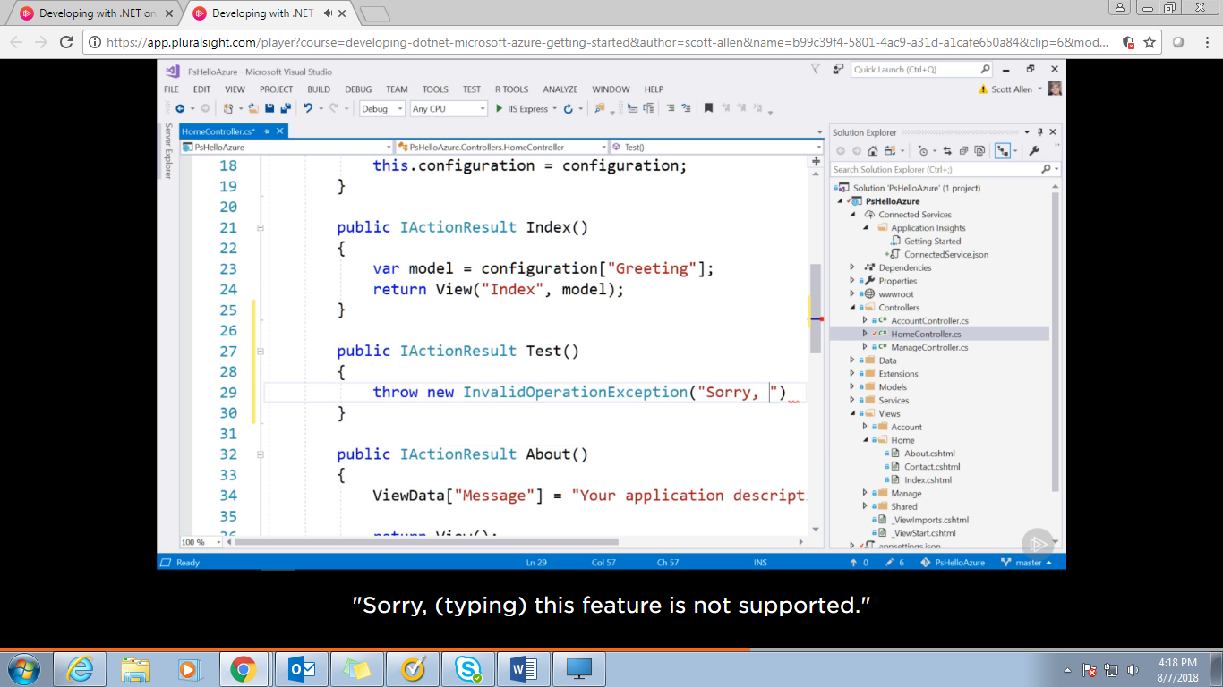

Home/Test request throw an exception which will be captured in Application Insight.

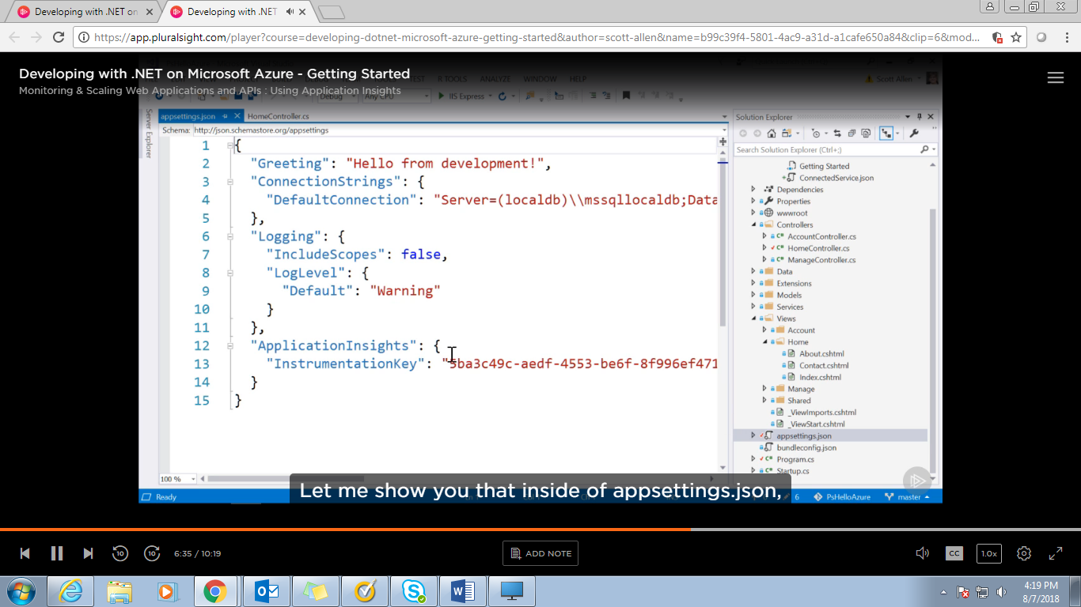

This key for Application Insight helps to correctly assign the exception to the correct App service.

Now publish the new code and see the application after making Home/test request.

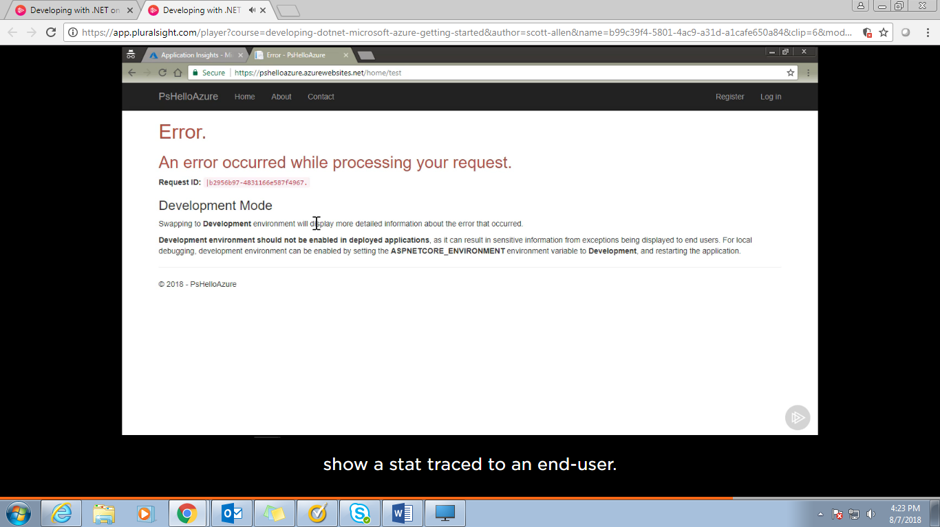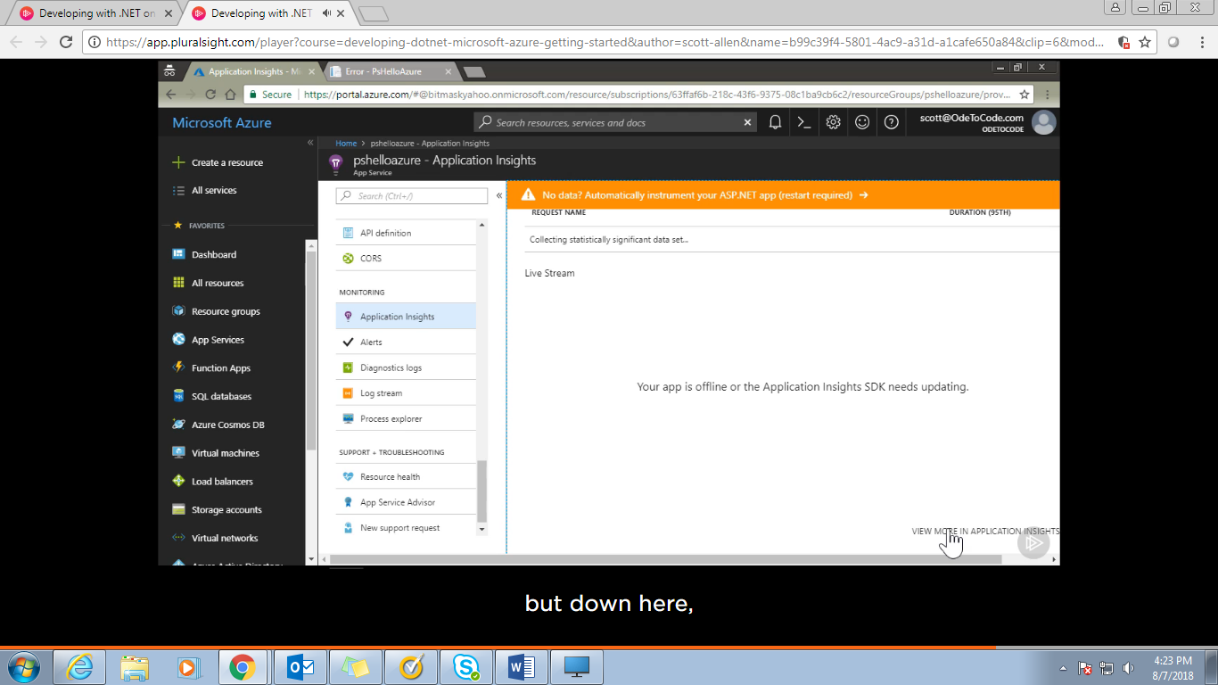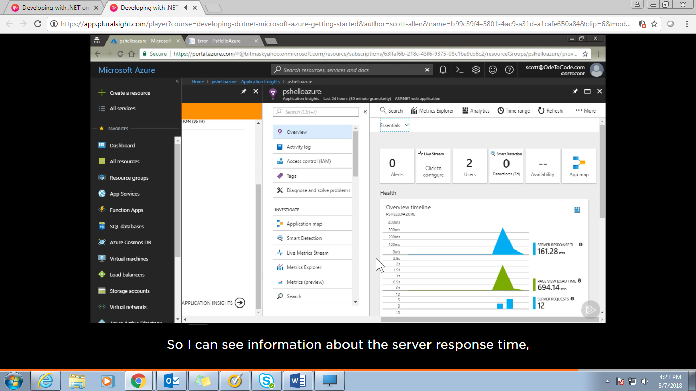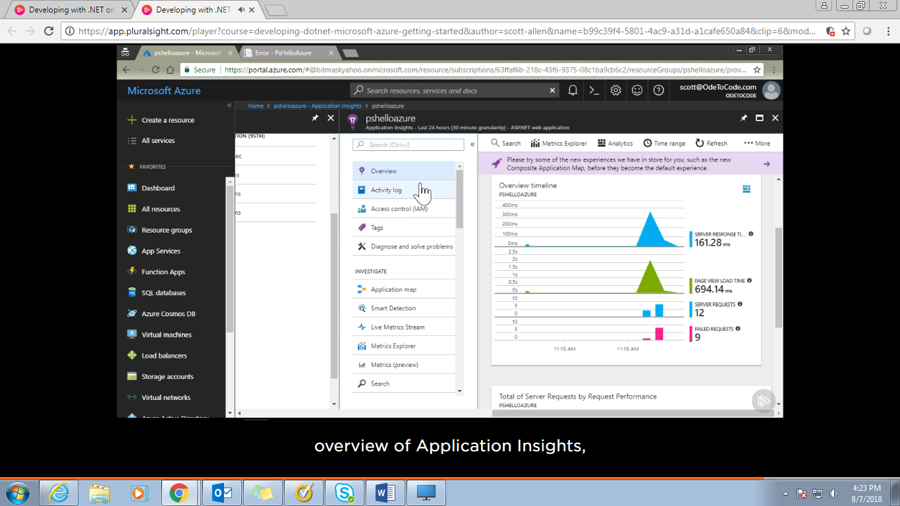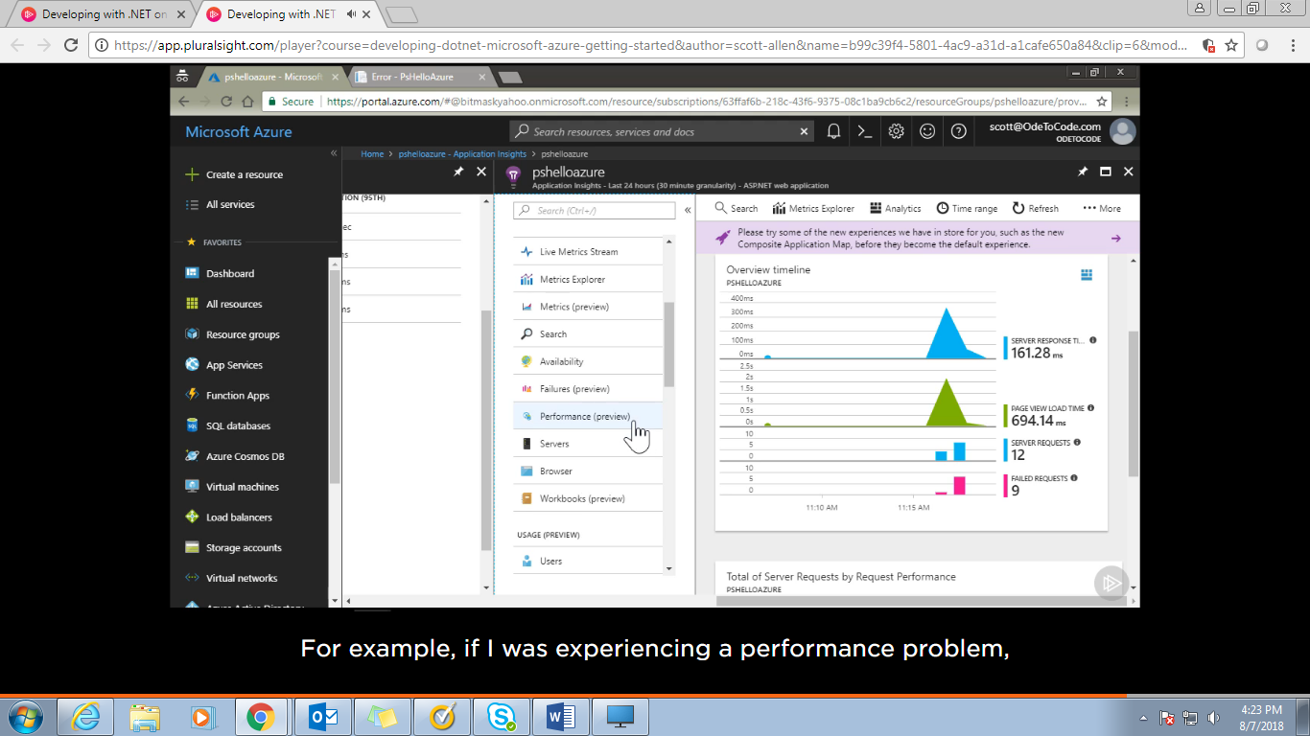

Seeing performance

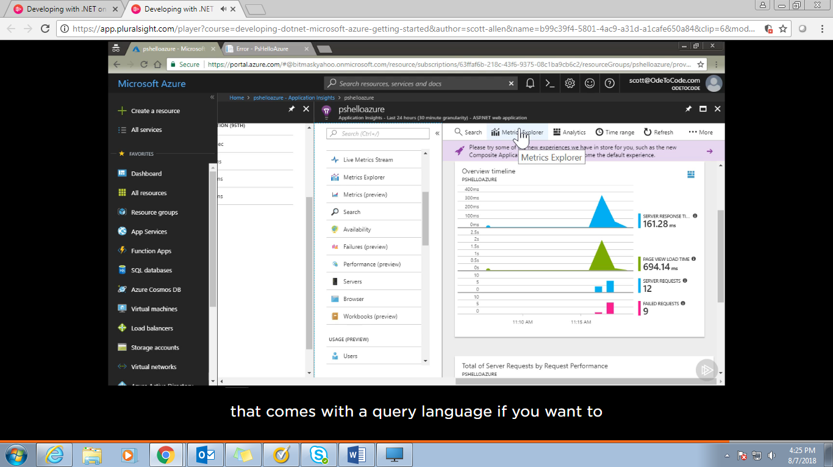

If u want to generate custom report for the data captured in Application insight –use Metric Explorer

Failure View:

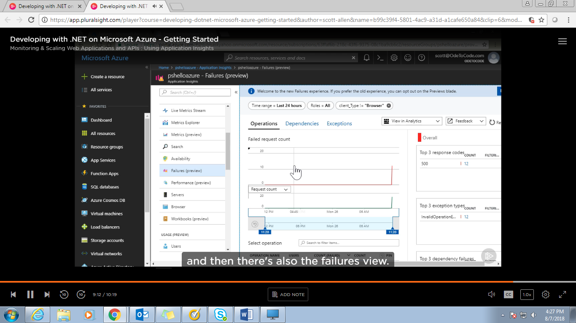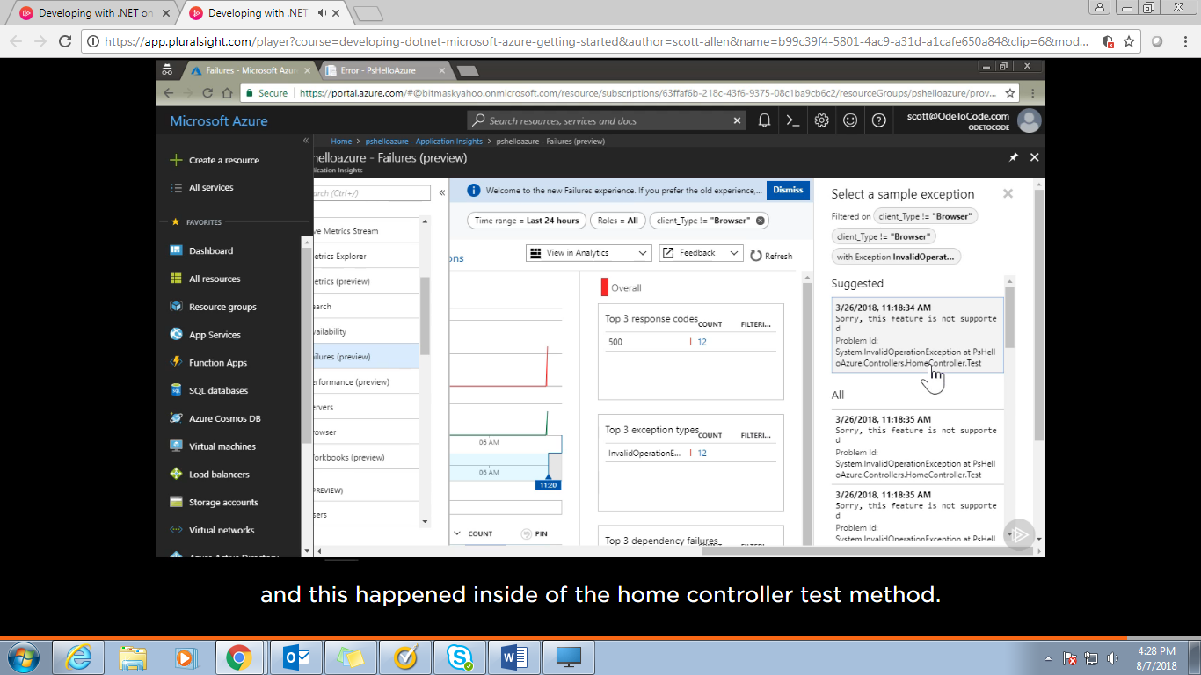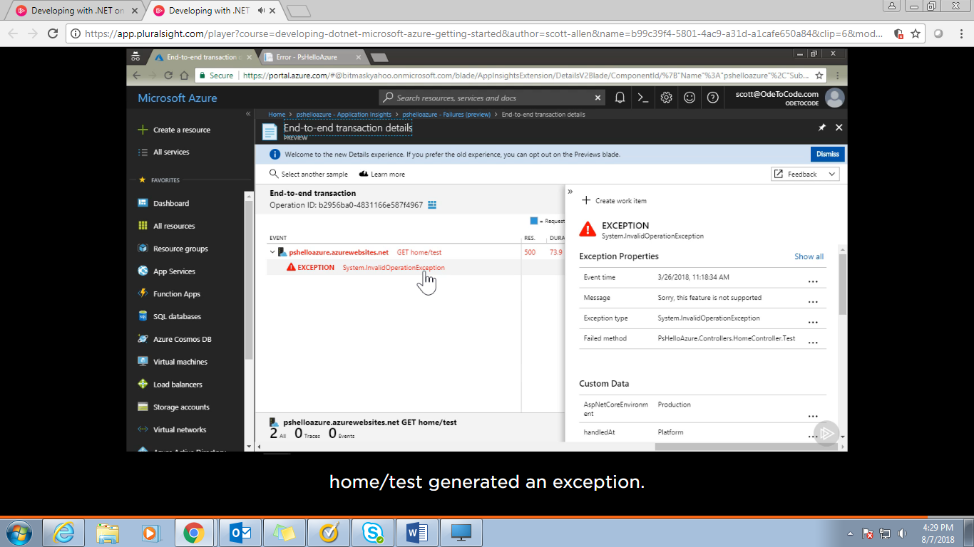

Debugging and Project Kuddu:

Azure provides us some advance tool to get closer to our server.

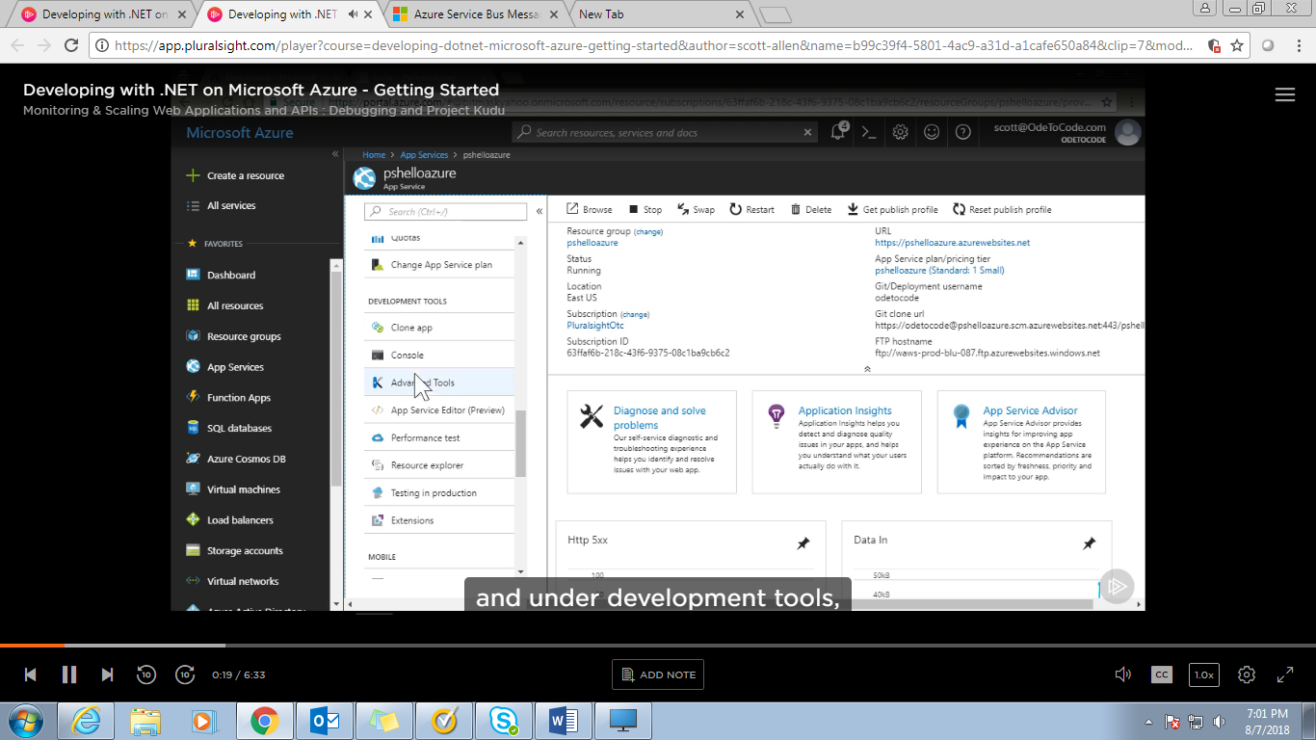

Development Tool🡪Advance Tool🡪Go🡪 we go to the next tab, kuddu project site

Direct link: Append .SCM with App service name like: <https://LPLChatBotService.scm.azurewebsites.net>

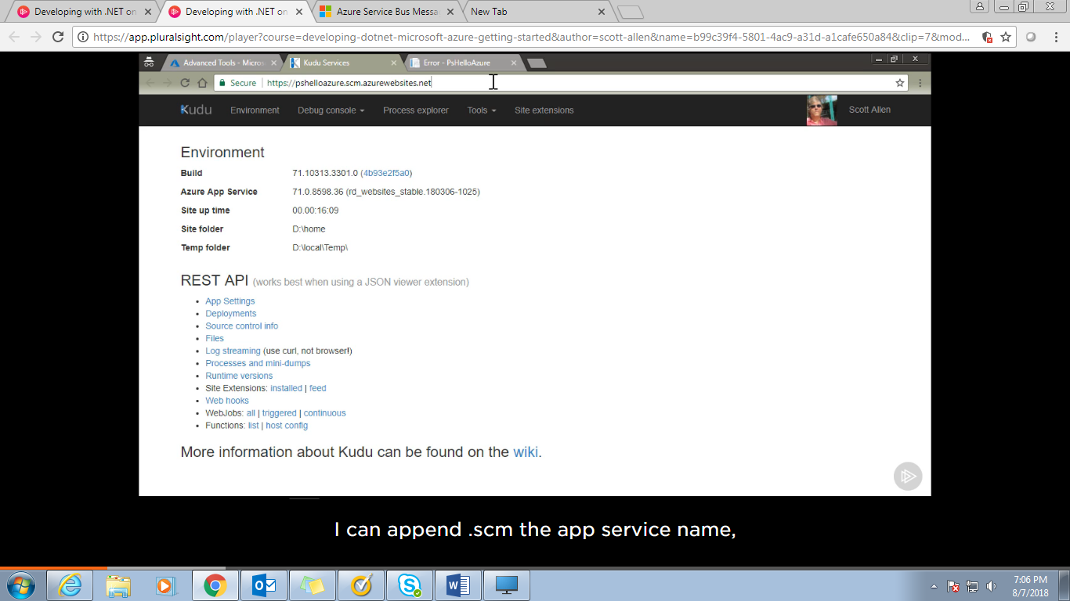

Kuddu will generate a build and deployment script for what type of project we are willing to deployment. It is working behind for the deployment process.

We can download the deployment script and customize it and push in got repository for deployment.

We can check every log file there in kuddu project or We can enable Remote debugging to see what is actually happening out there.

Application Setting🡪Debugging🡪 remote debugging 🡪ON🡪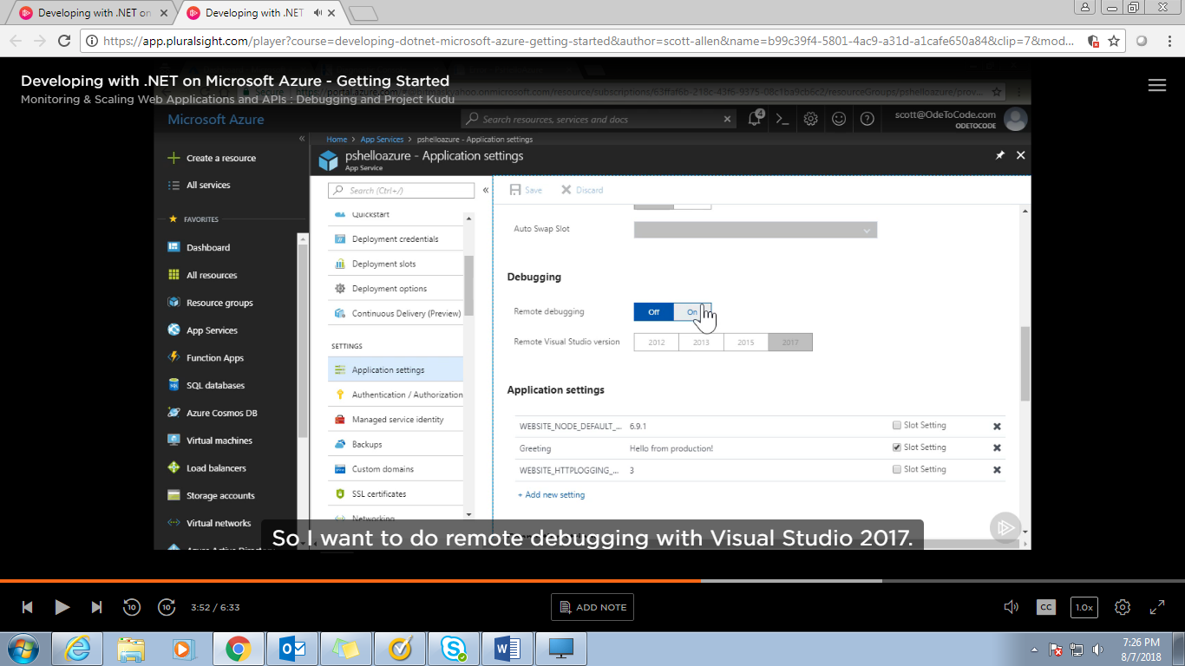

save the change made🡪come to visual studio🡪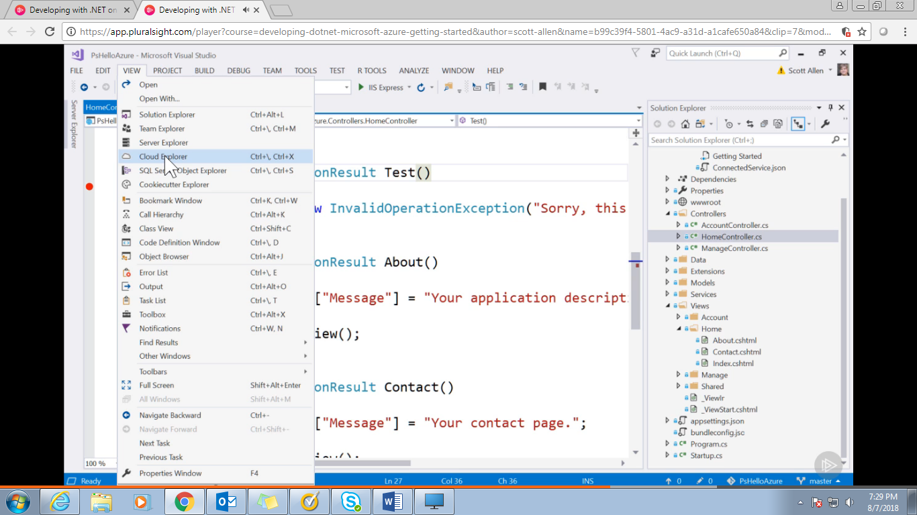

Cloud Explorer🡪

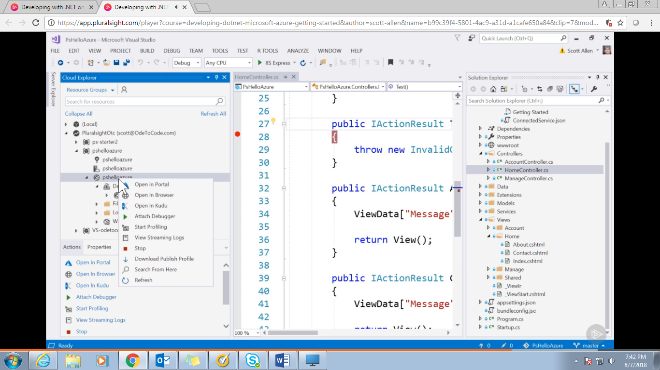

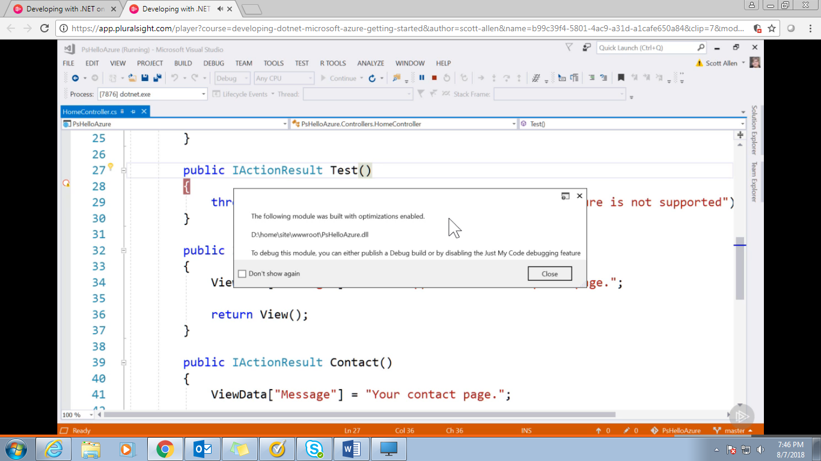

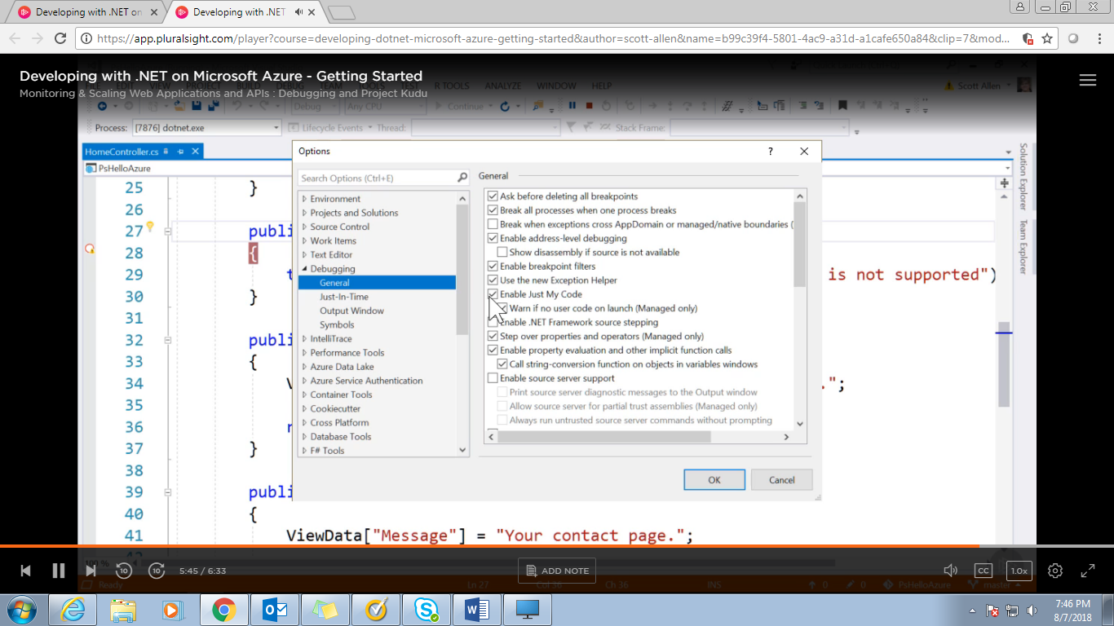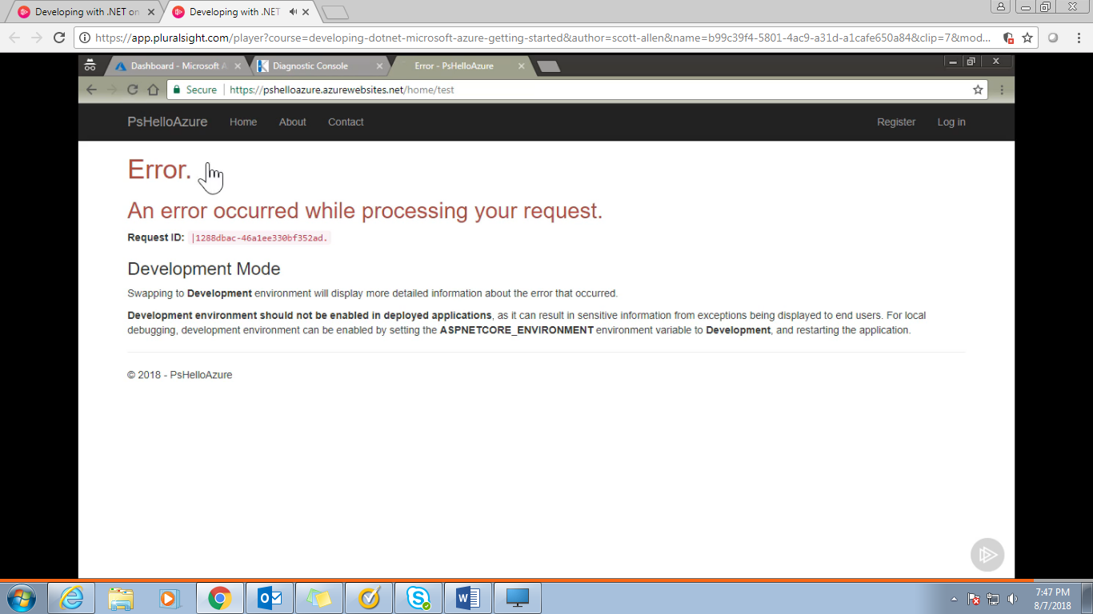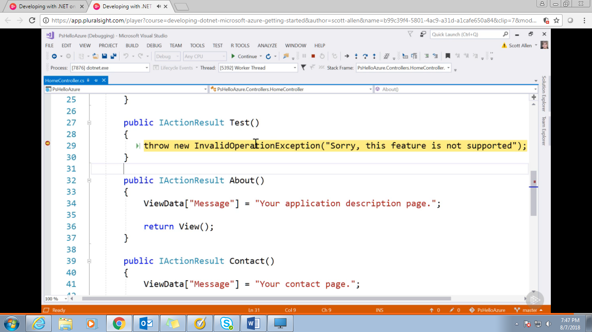

**Using Cloud Databases:**

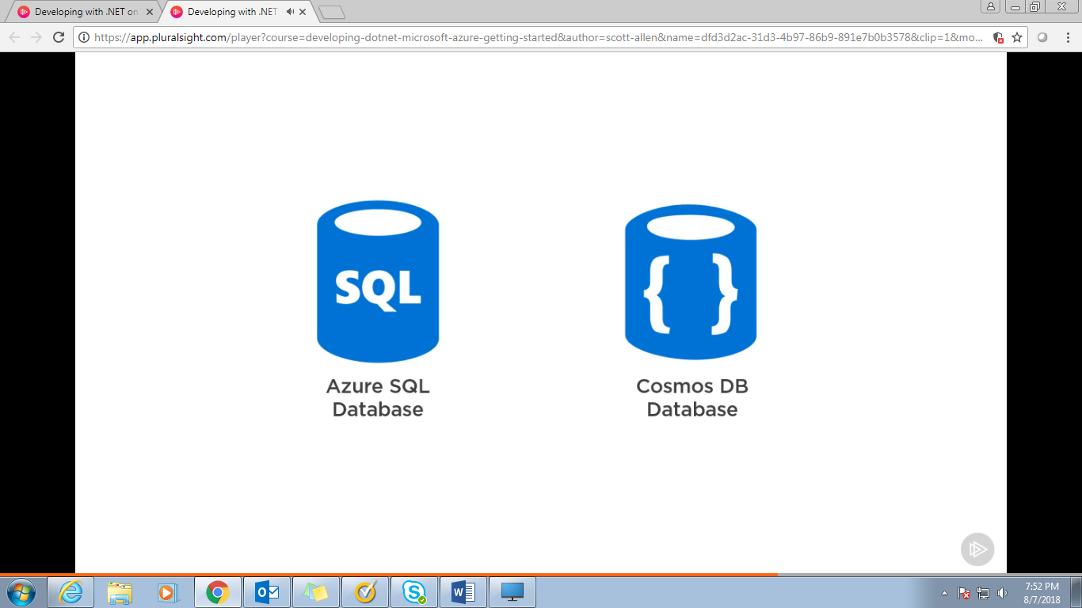

Cosmos DB: Use document in Json format , No table and schema there so its flexible

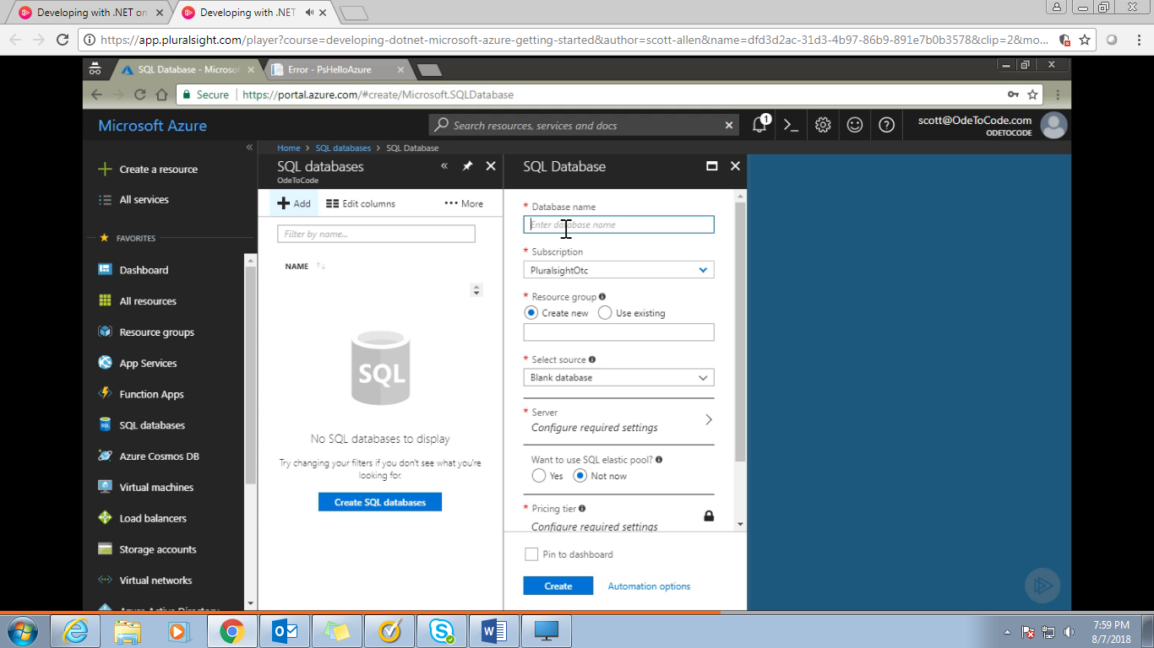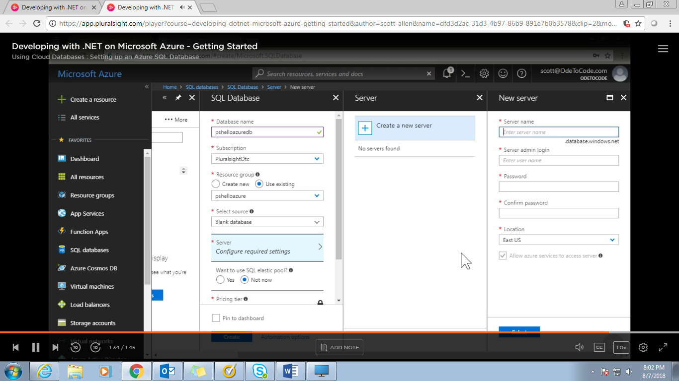

SQL server in Azure means:

Every database that we create in Azure needs to be associated with SQL server but don’t think that this Azure SQL server is a physical server or virtual server. Azure SQL server is just a name that you gave to a logical container of one or more databases. Databases that we associate with Azure SQL server may or may not live in same physical or virtual server. We just need a name so we are giving this name here. 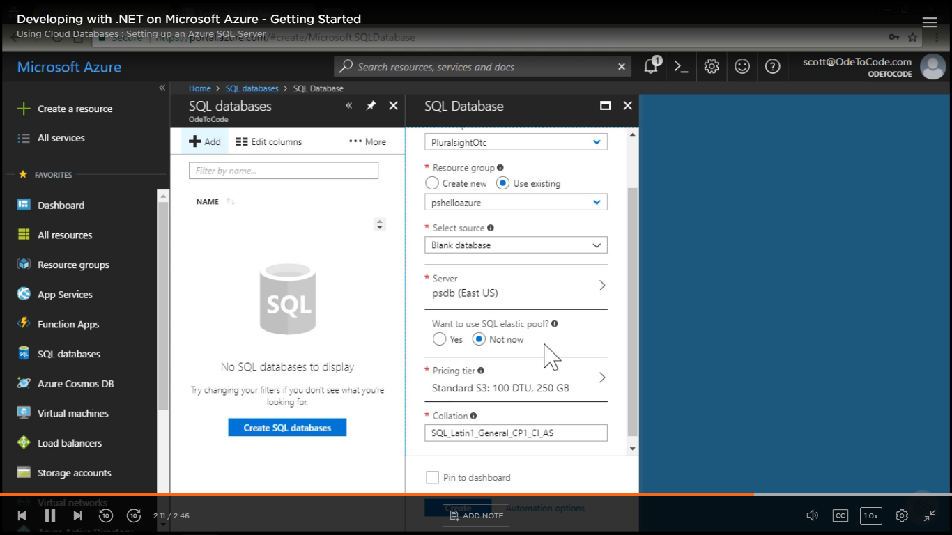

Allow you to provision resources inside Azure that youb can spread across multiple Azure SQL detabases and ultimetly elastic pool allow to handle spicky traffic and heavy load. For single detabase we don’t need elastic pool.

DTU—Data throughput Unit is how much power available behind the database and DTU is blended mix of memory and io.

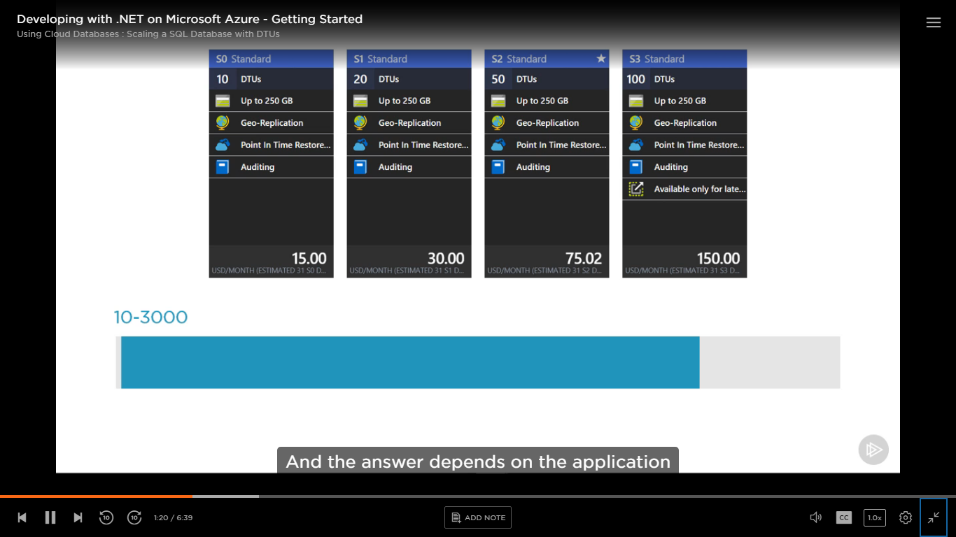

Websites with 25000 pages’ view and each page view generates one or two queries, a standard database of 10 DTU is more than enough. 3000 DTU is 300 more powerful than 10 DTU database.

Azure SQL data house or Azure SQL data lake if more than premium DTU required.

Pricing is assigned to database level not on server level.

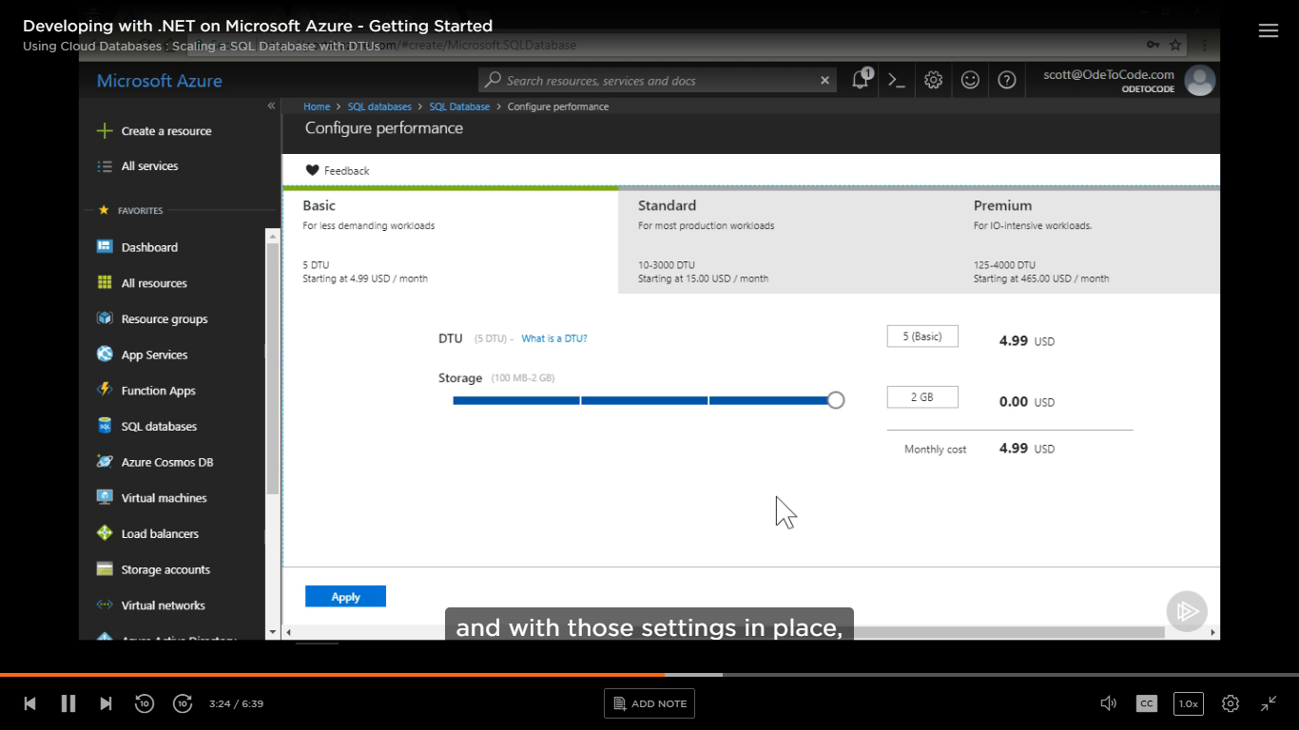

See databases:

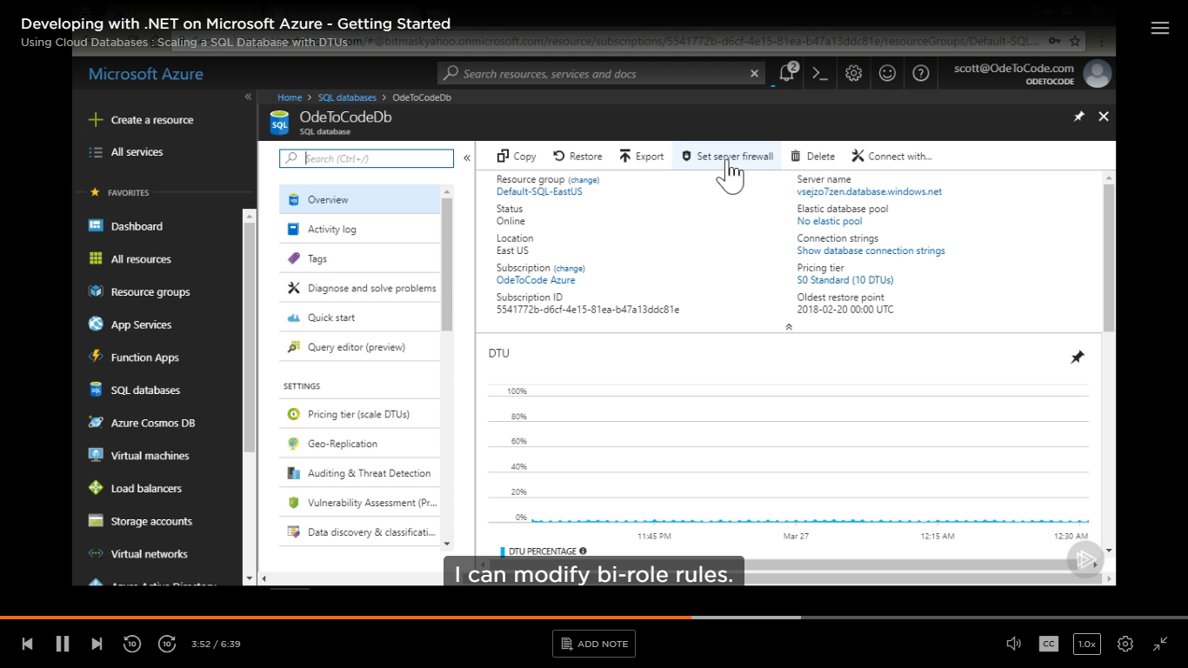

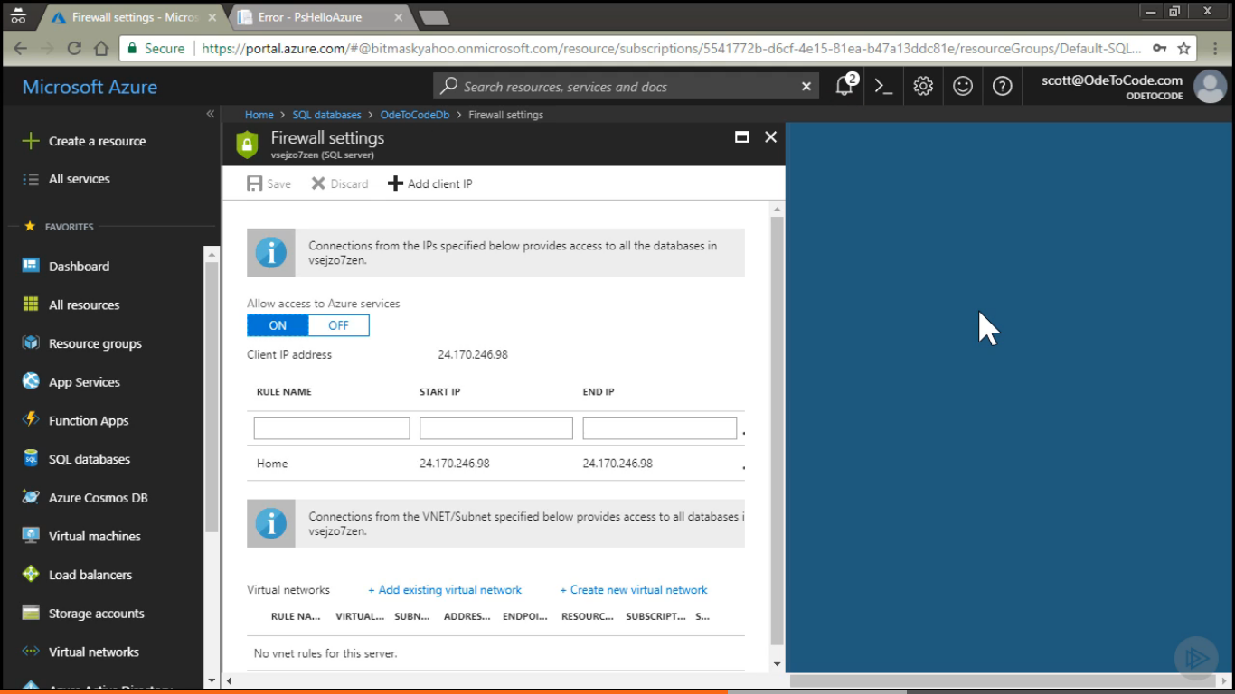

Allow access to Azure services and for outside of Azure we are bounded by IP Address.

DTU percentage here🡪

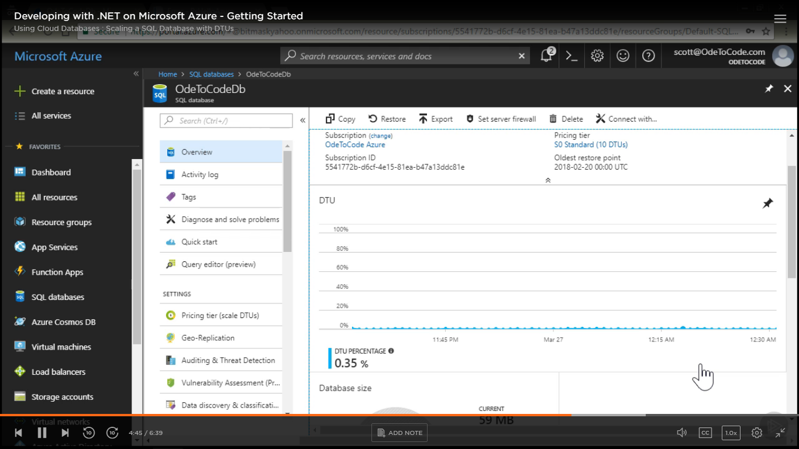

Database Size🡪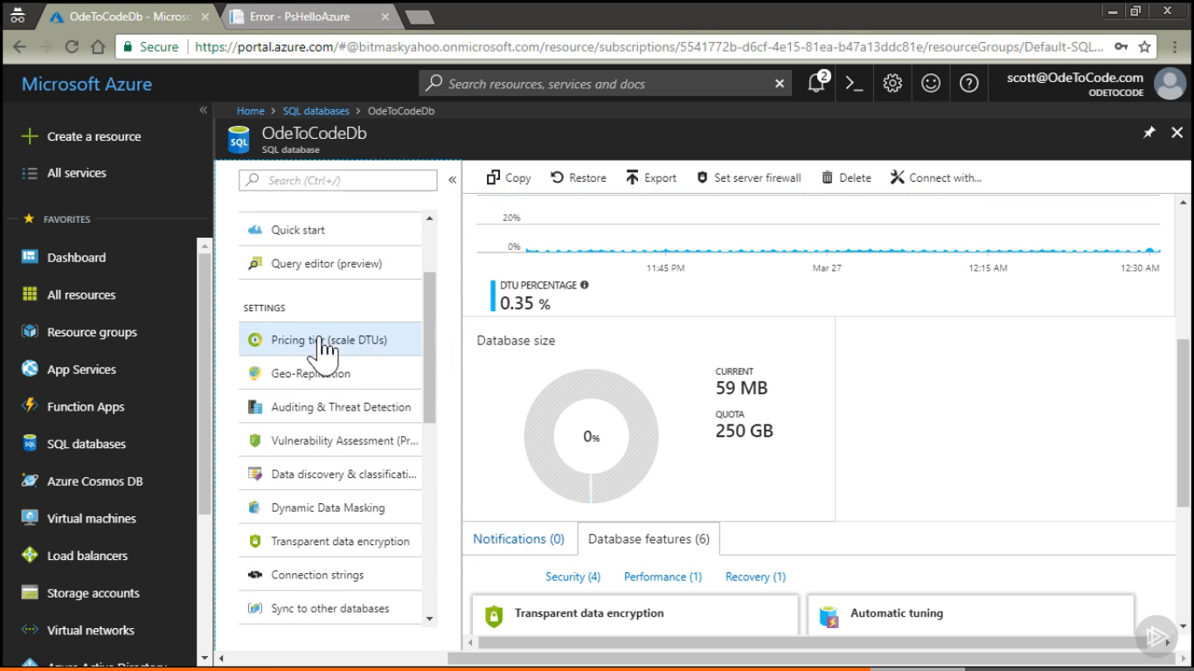

Settings🡪Pricing Tier, Geo Replication, Transparent data encryption—here

Monitoring🡪Alert Rule on bases of no of DTU used

Connection String: In Overview section we can have server name

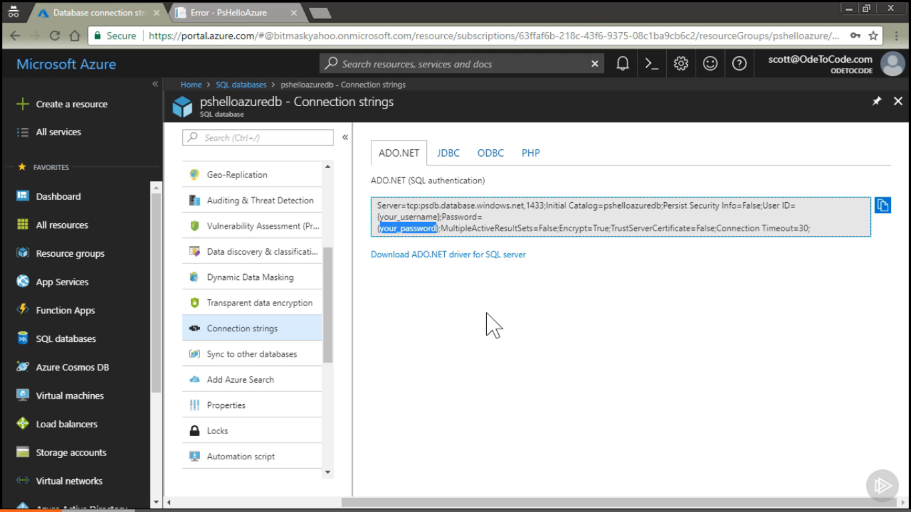

Currently only admin login is there so to avoid admin login sob create and login for my application.

SSMS can interact with Azure Database or through visual studio also,

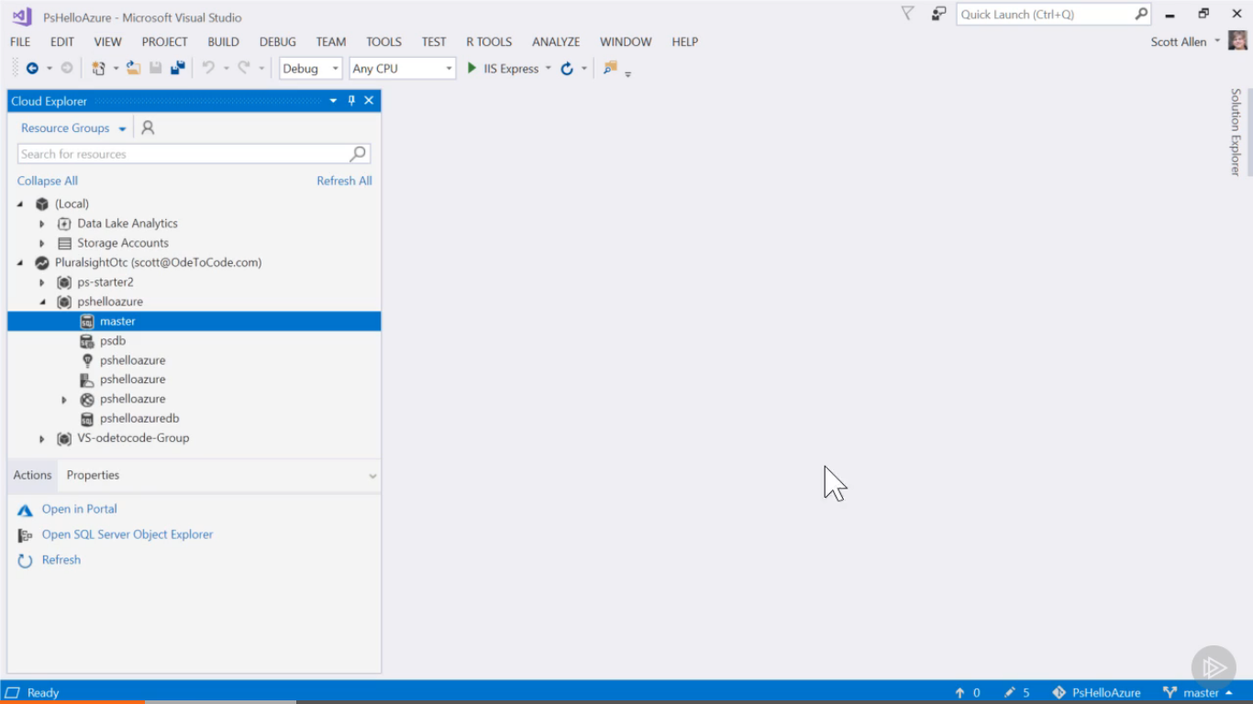

Pshelloazure- Resource group

psdb- SQl Server

master,Pshelloazuredb-databases

master database contains login accouonts for all the databases attached to psdb server.

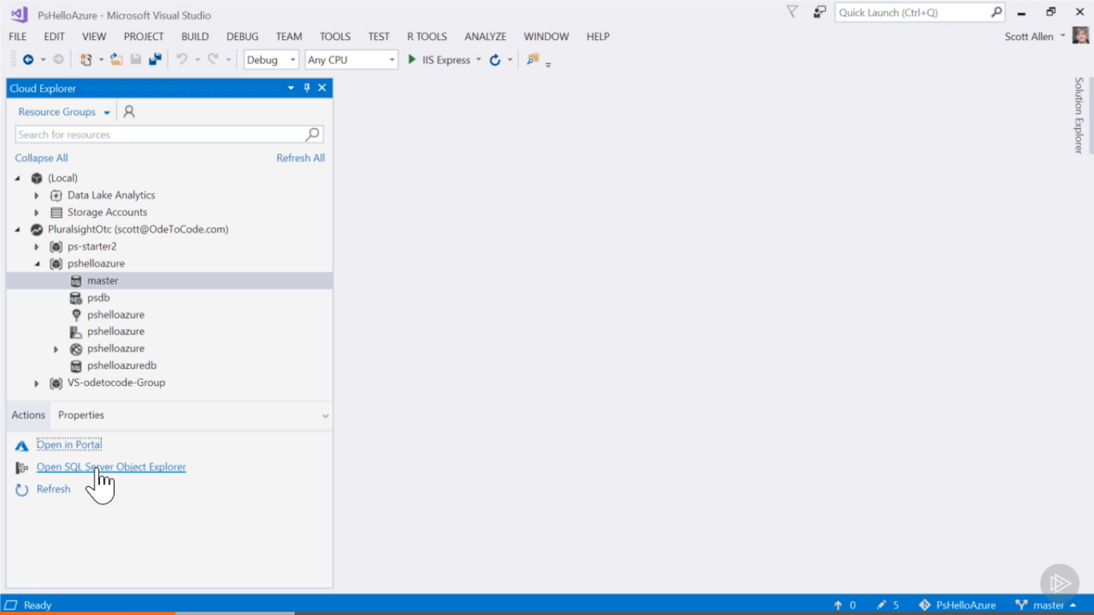

Select database here and click on open SQL server object explorer.

OR🡪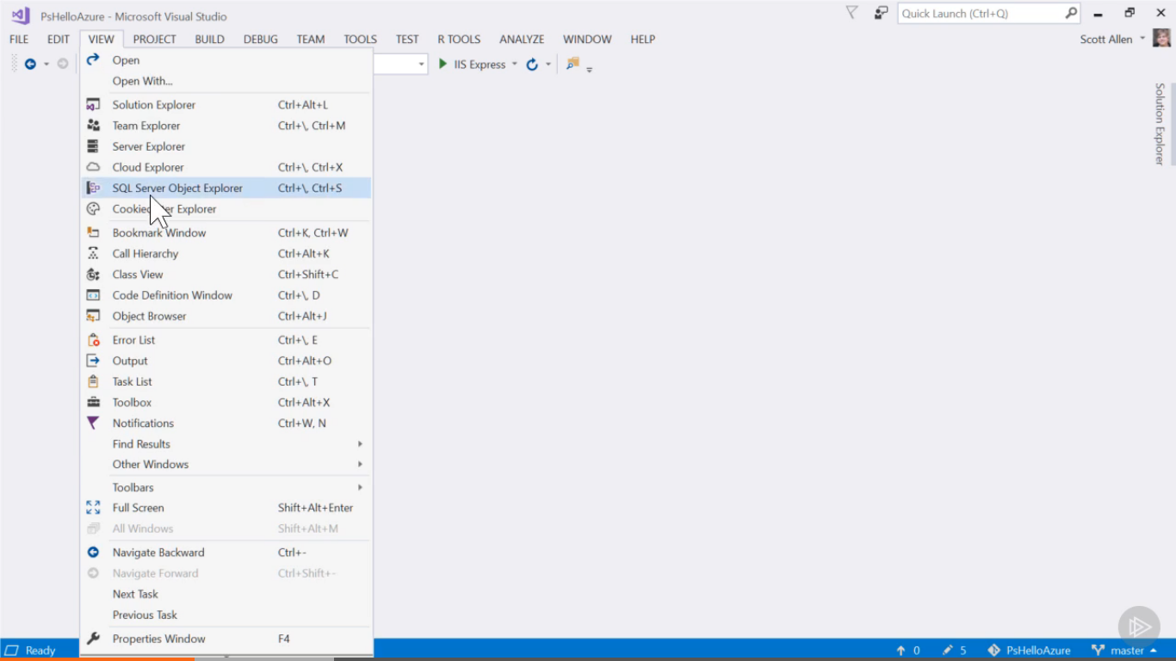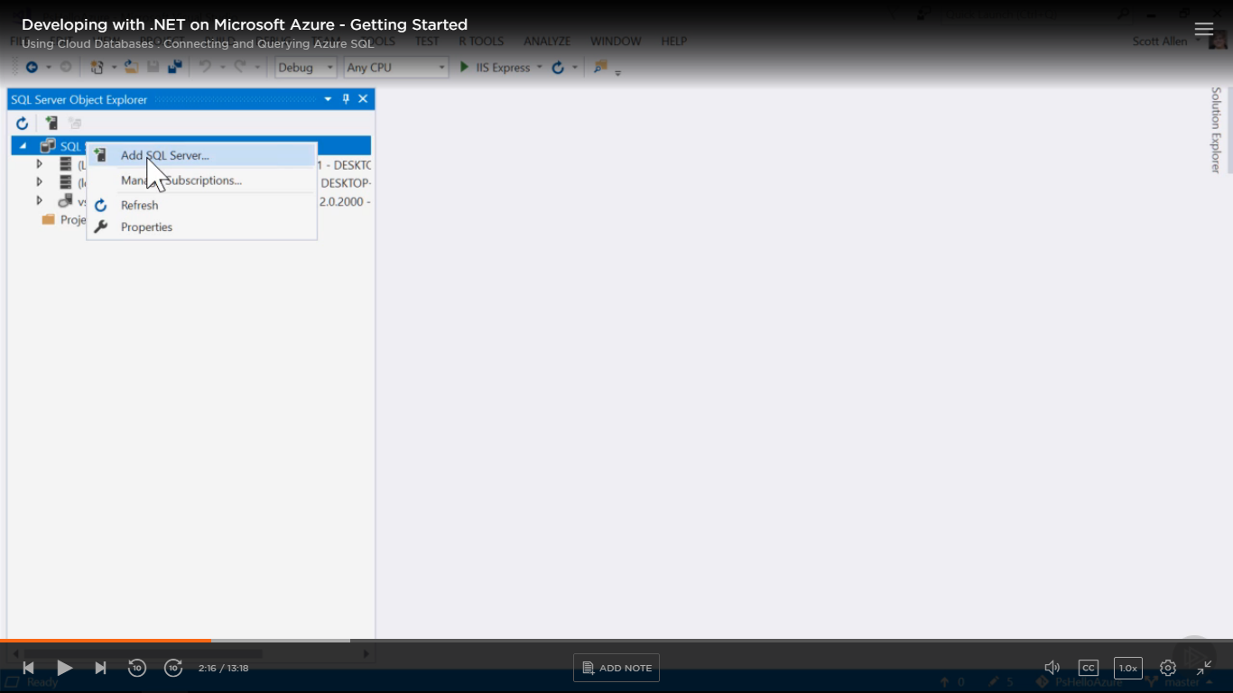

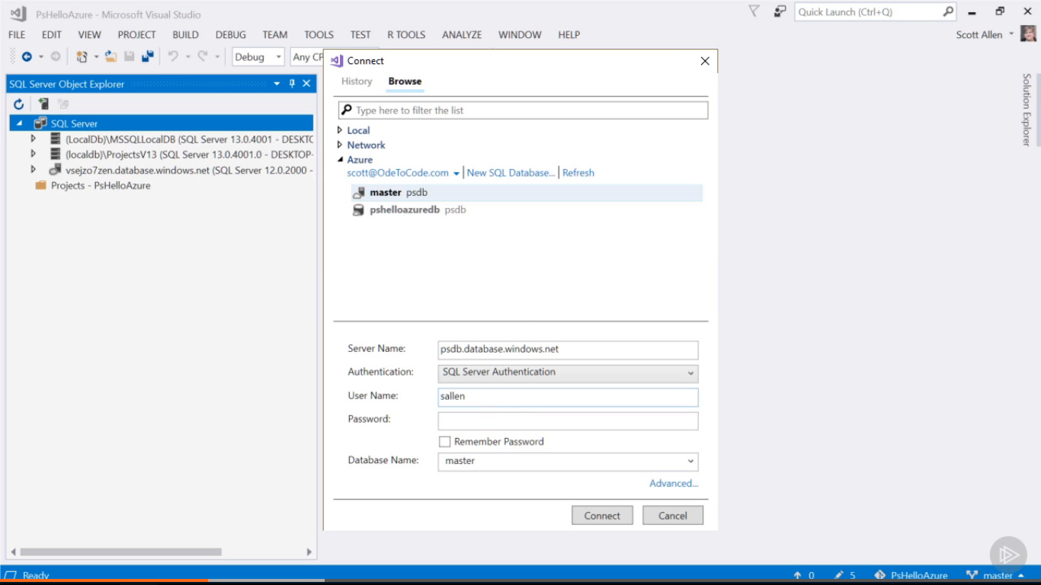

First Select master database to create login for application. 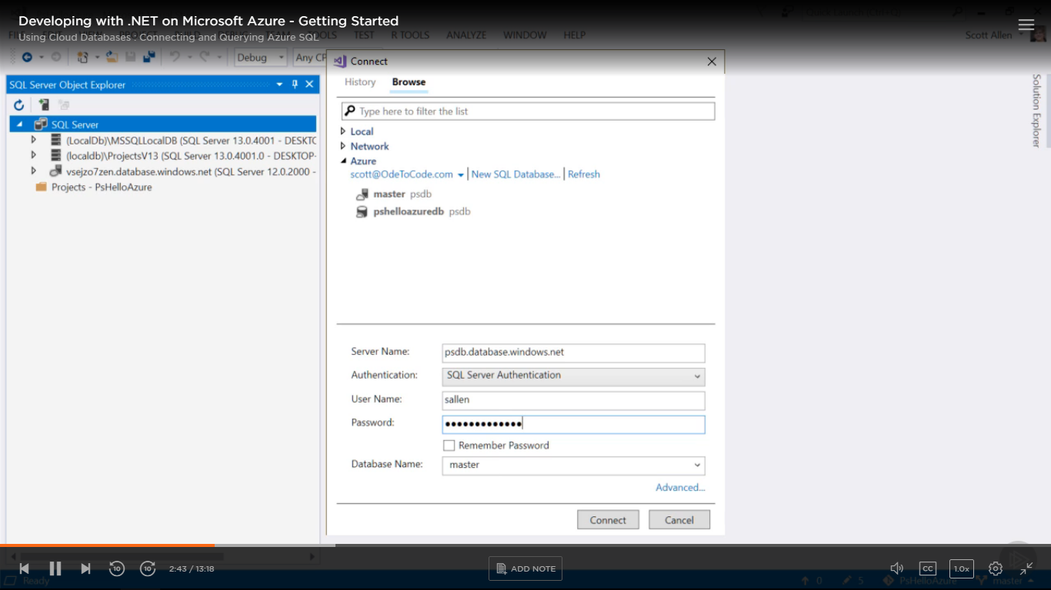

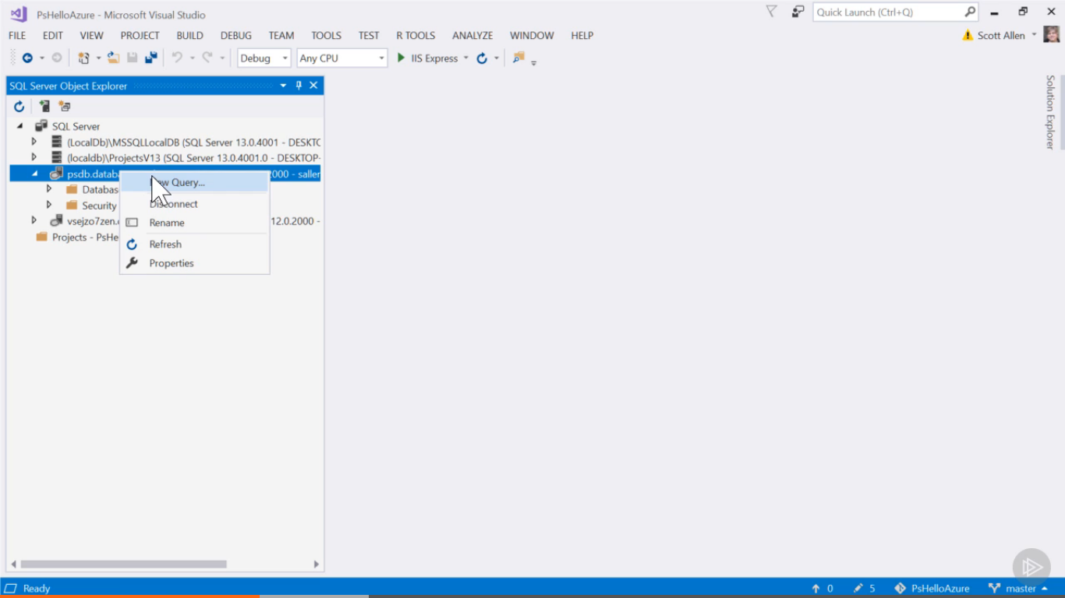

Creating login for application with user and password

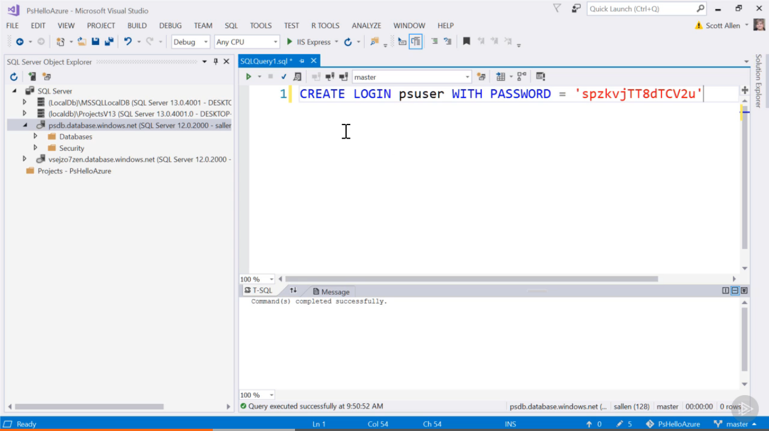

We can’t use ‘USE’ command to switch between databases. 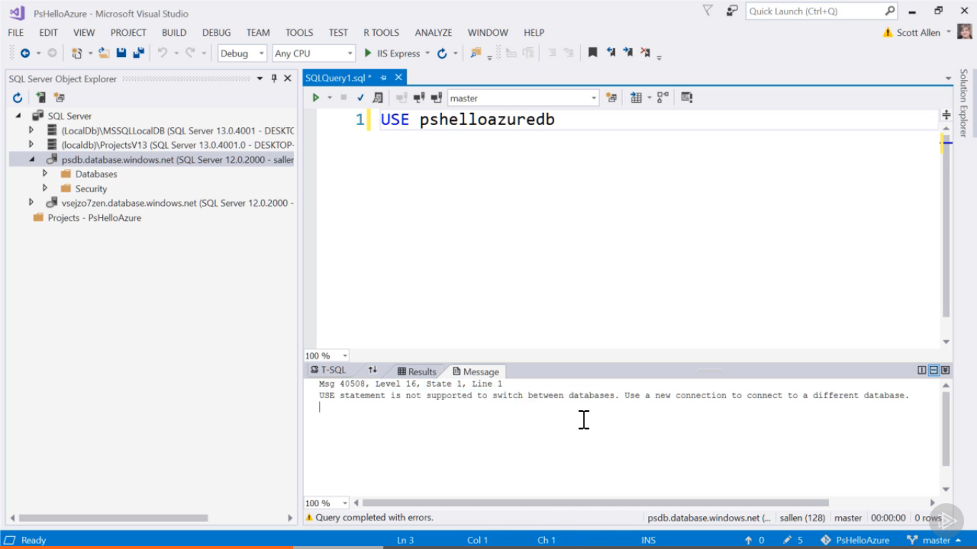

So connects again with server and select other databases. Using admin login Id and password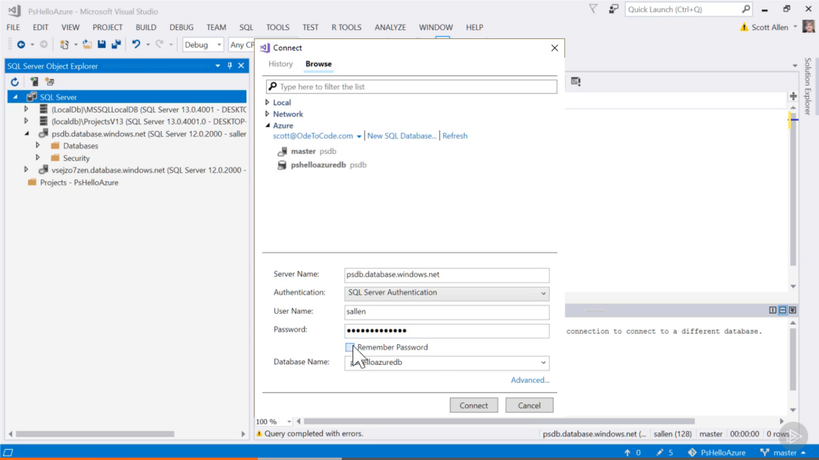

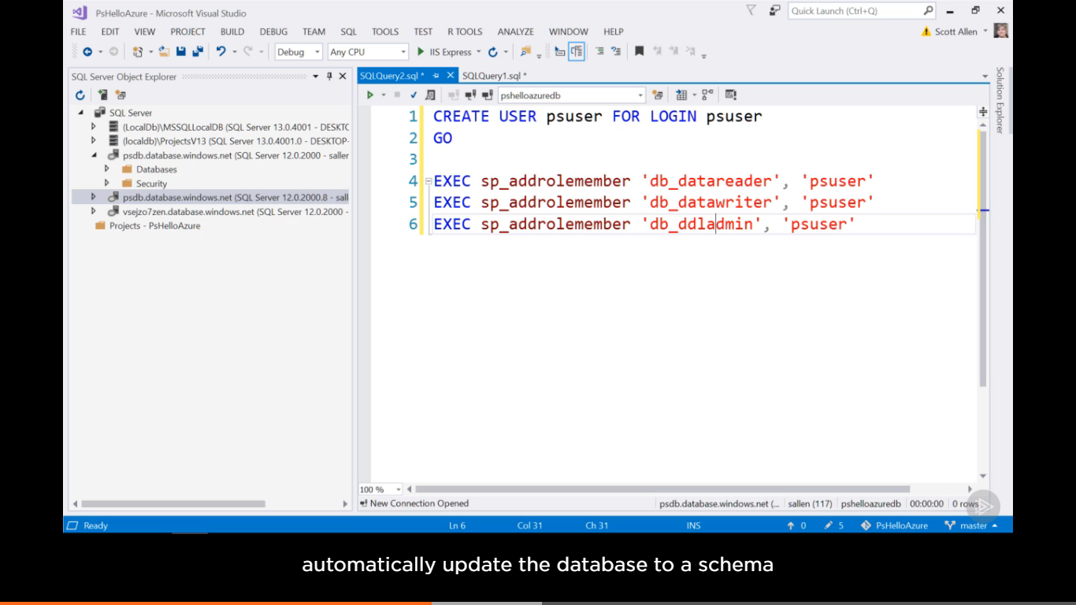

Connecting to psazuredb and write query

1st line🡪creating user psuser for login into master db which was psuser

4th to 6th 🡪adding user to different role here like reader, writer and ddladmin

Now if we use entity framework for migration of data in database or writing DDL script in SSMSO.

Now we are connecting with database in visual studio application to connect to right database

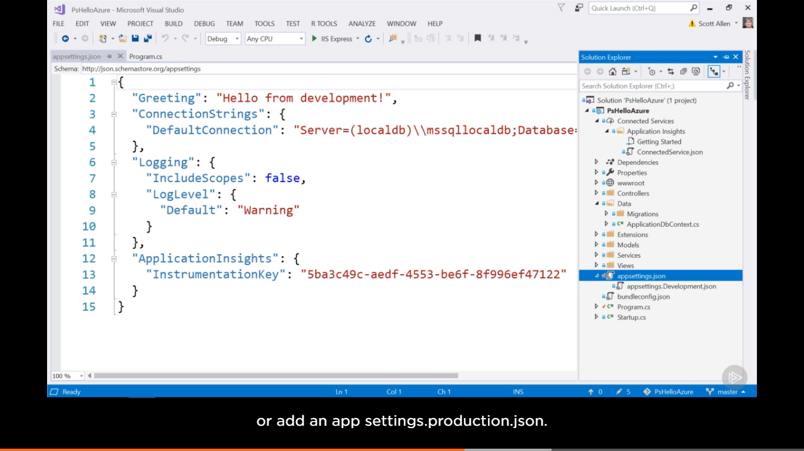

Here in connection string use cam use default connection to connect to azure database or if we don’t want to add the connection where it will be there in source control we can have a different approach here by placing the connecting string in AppSetting of AppService. Also we can use Azure key vault to manage secret information.

App Service🡪settings🡪Application Settings🡪App settings🡪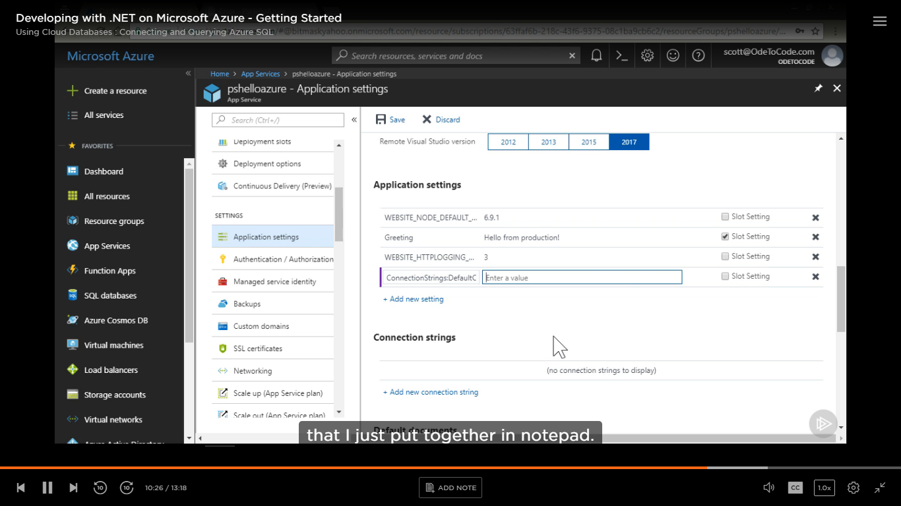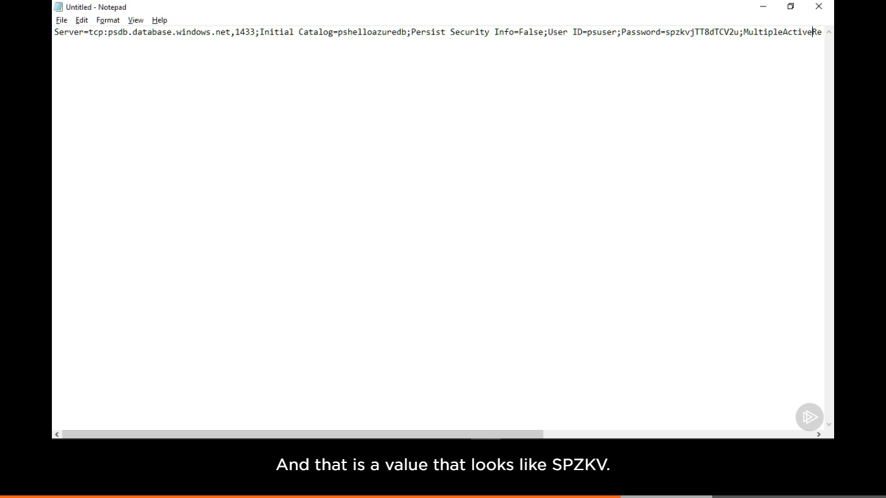

Before adding in app setting we need to edit connecting string add username=’psuser’, password=’the one we set there in master database’ and multipleActiveResultSet=’True’ (if entity framework is used)

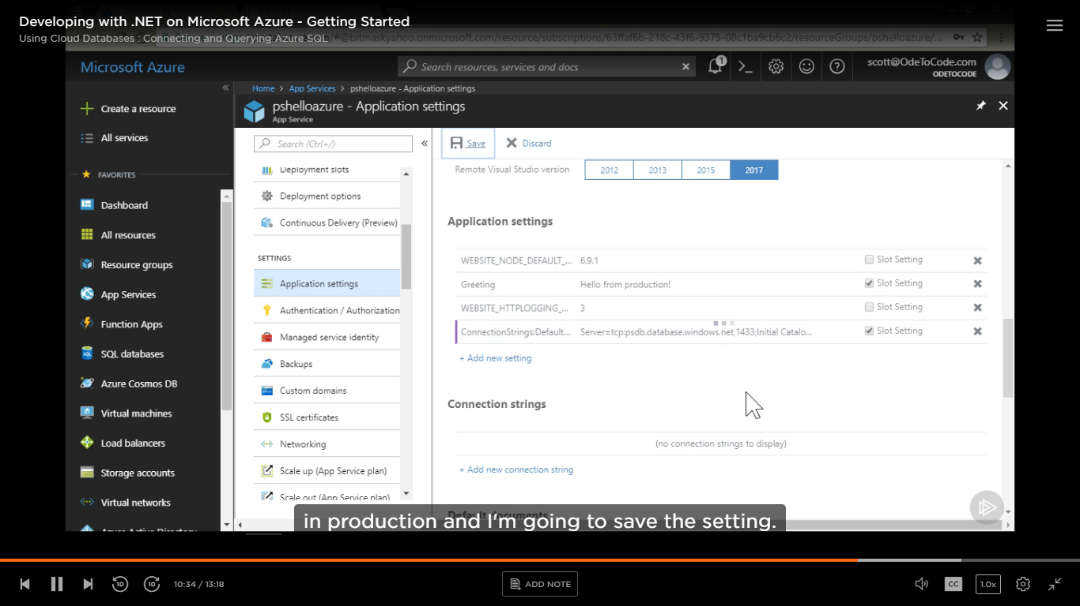

Now will deploy the application and entity framework will create all the table and we see the data stored in the table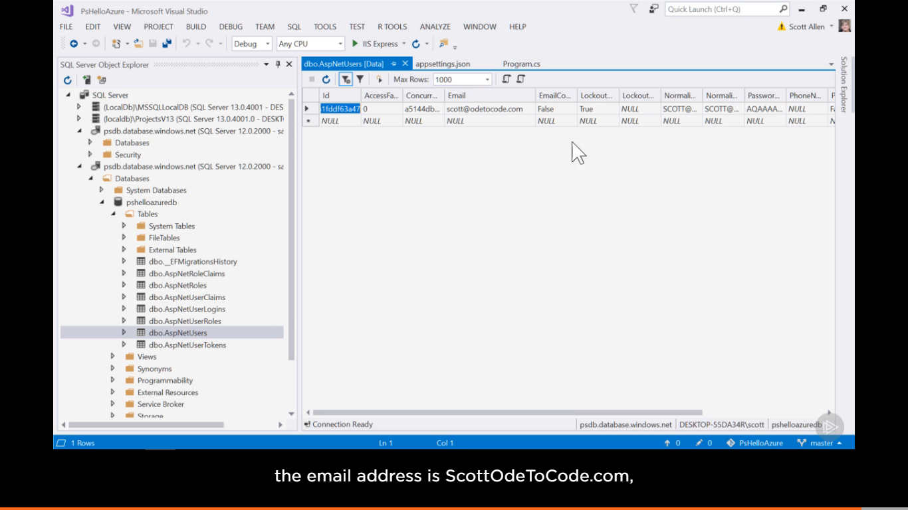

Azure Cosmos Database:

Will create Azure cosmos database, we don’t pay for server we pay for the database inside it.

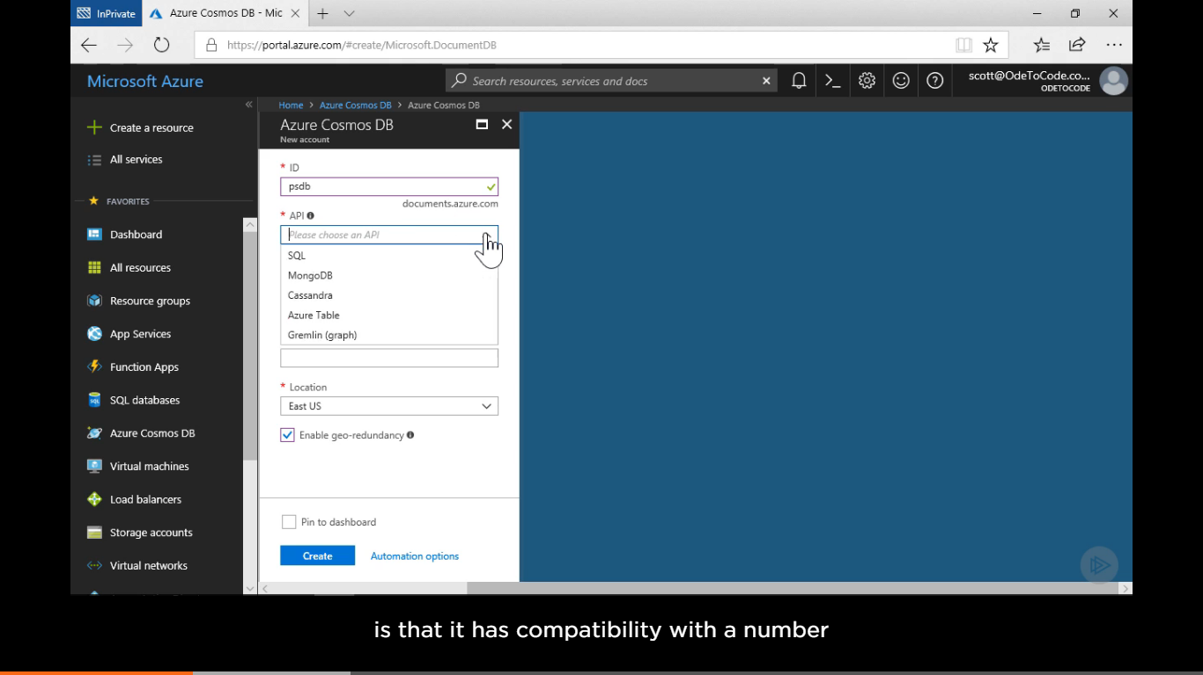

Cosmos server(this is an account)🡪databases(one or more databases may be there)🡪Collections(can have one or more collection)🡪collection has no schema so can store any type of documents there.

We can have multiple collection based on their uses and performance needed

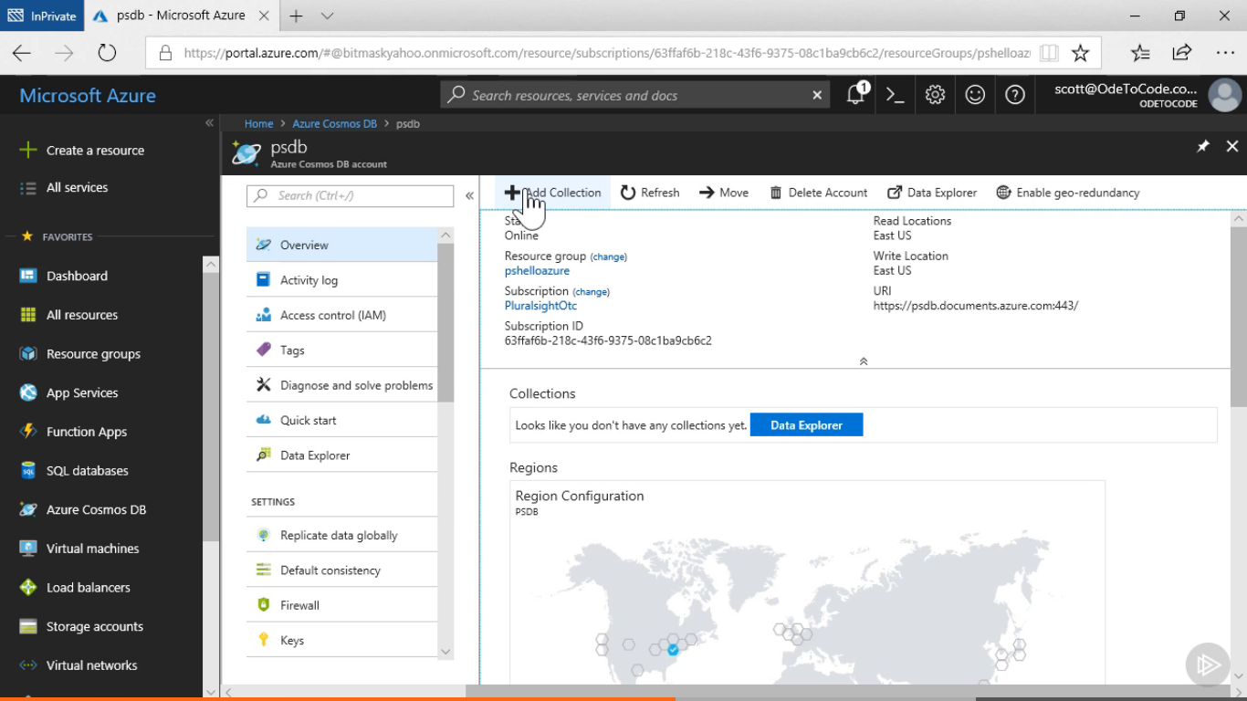

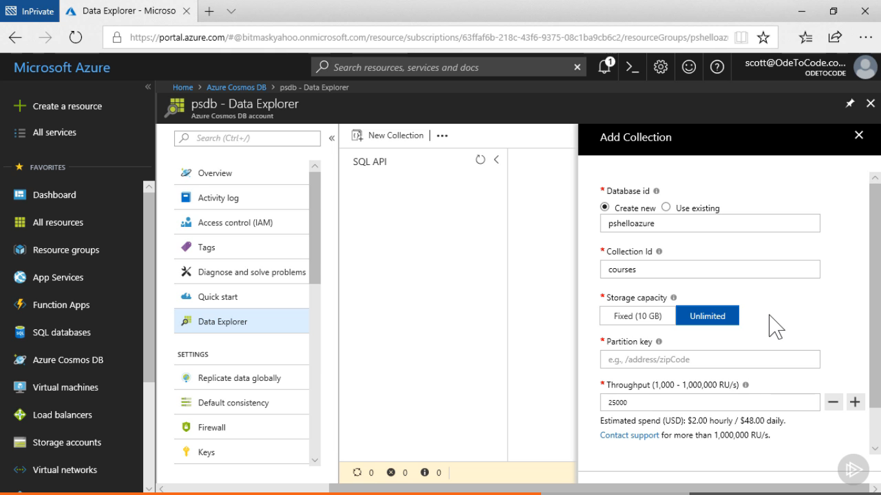

1st add database in database Id as pshelloazure then collection Id as course

Partition key is used to spread data across multiple resources.

Throughput—request per second(RU-request Unit) 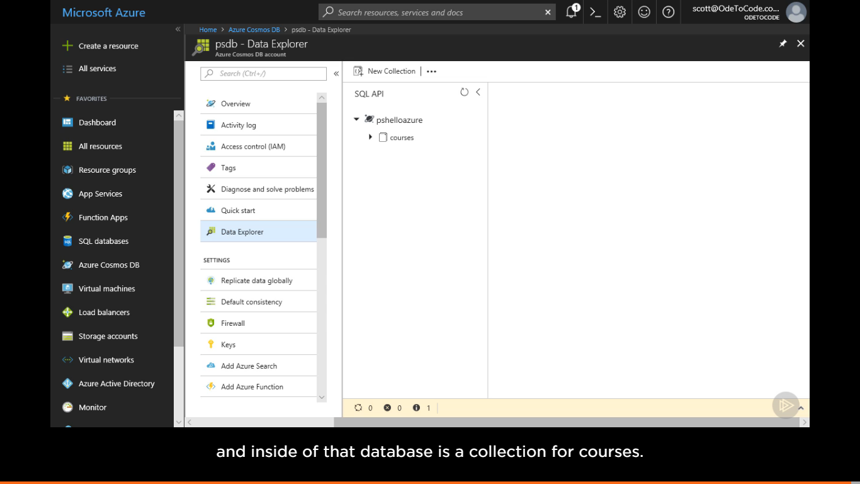

Now see how to use this from our application 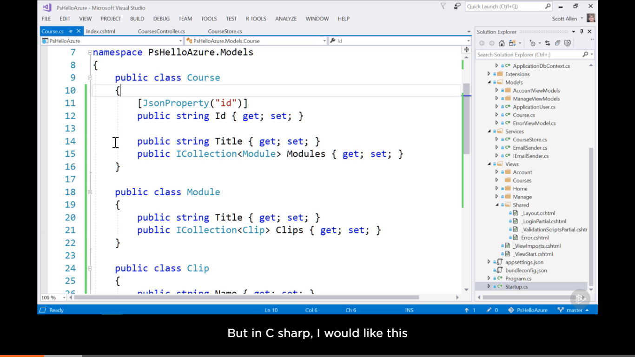

Cosmos db use lower case id to identify so managed here. 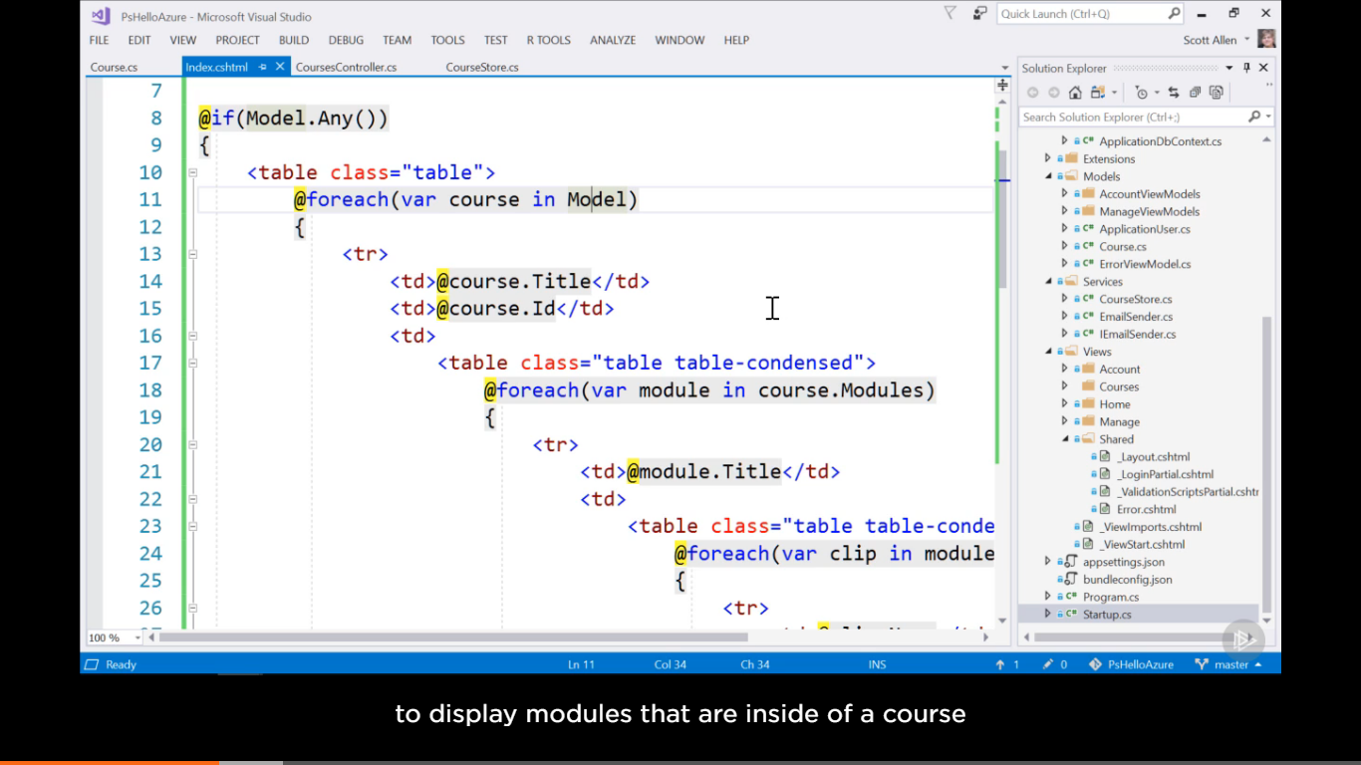

Code to fetch data from documents 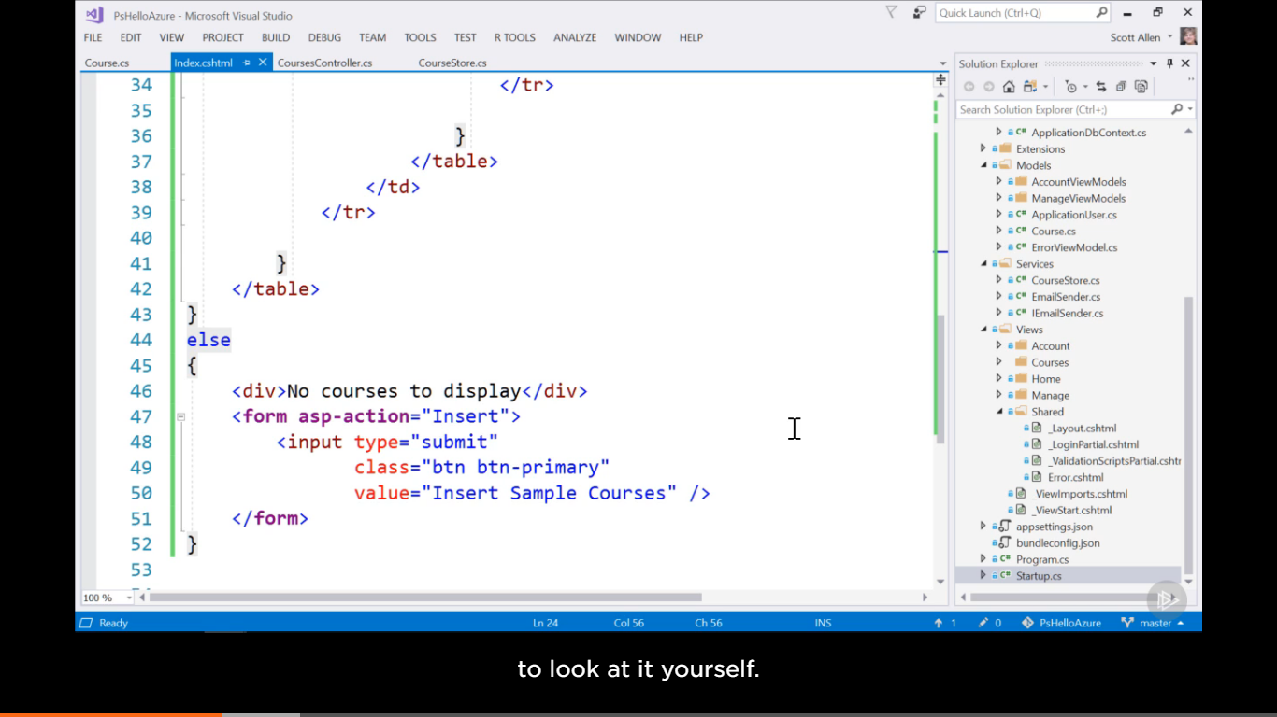

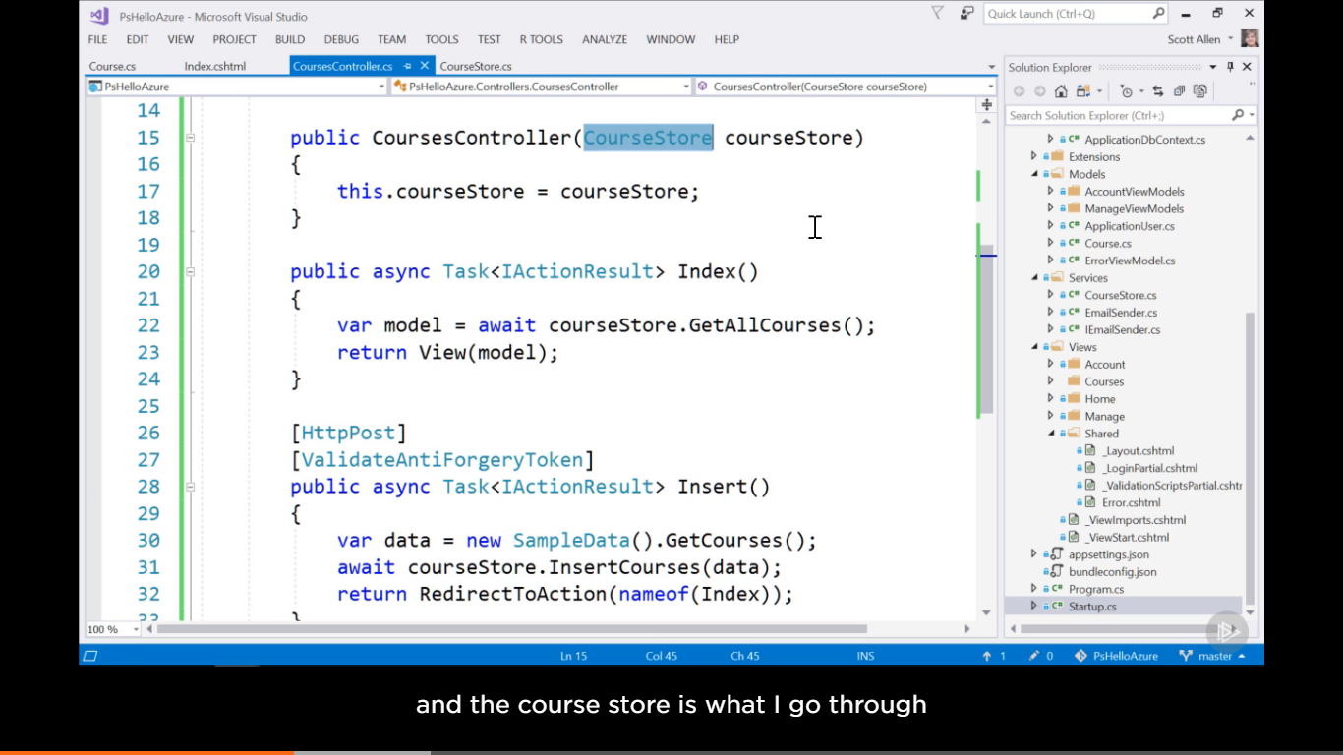 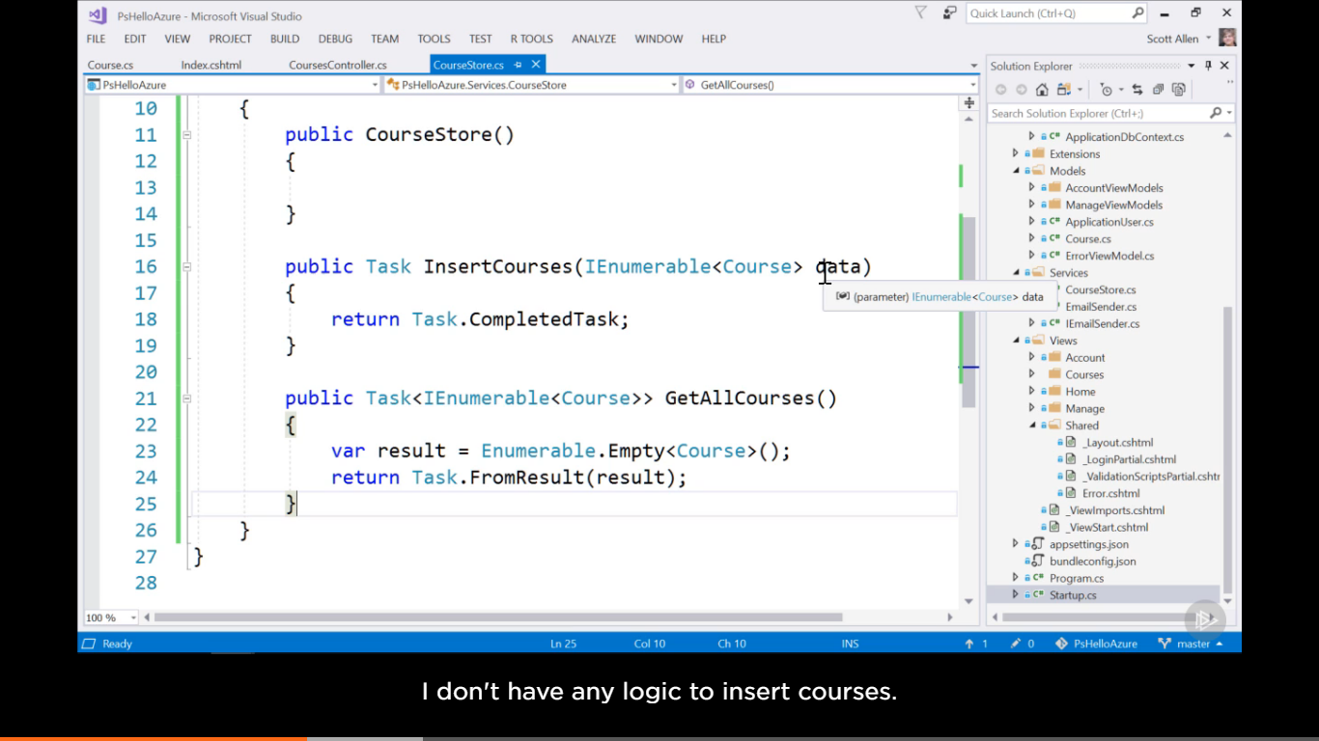

Now we write code here to interact (insert or fetch data from database) with cosmos database either by API call or using a nudget pacakages. Here using package 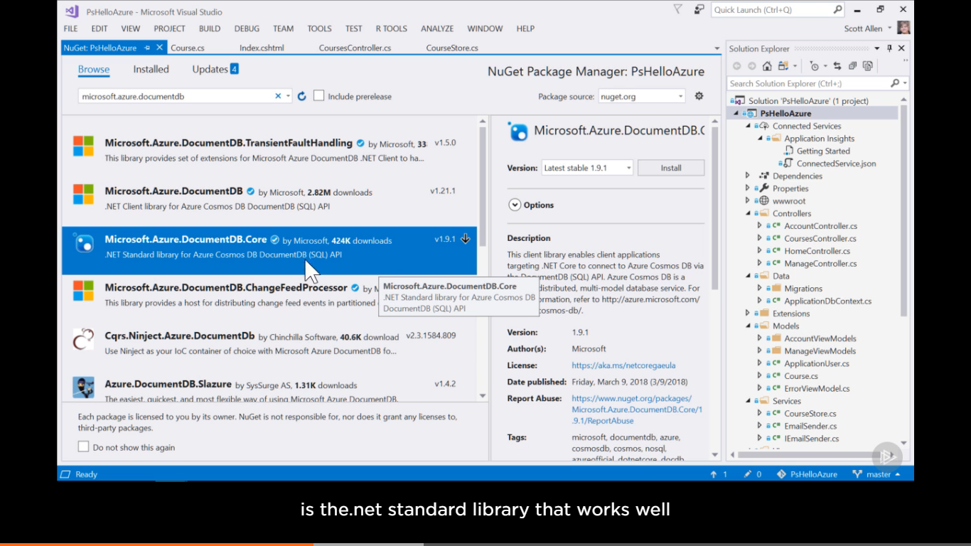

This is for .net core

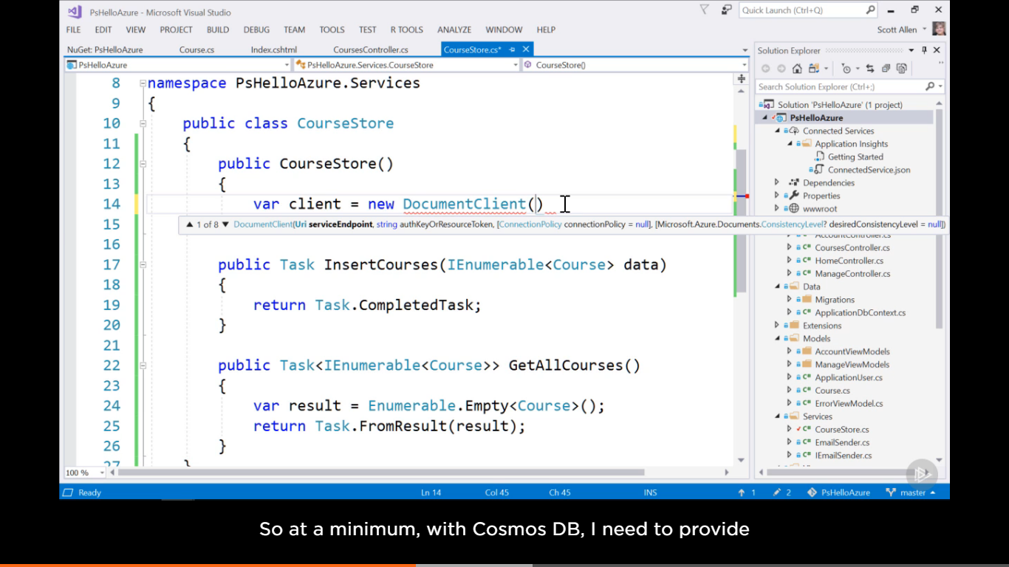

1st we add a client class and then call the methods. Here we need to pass service end point and auth token 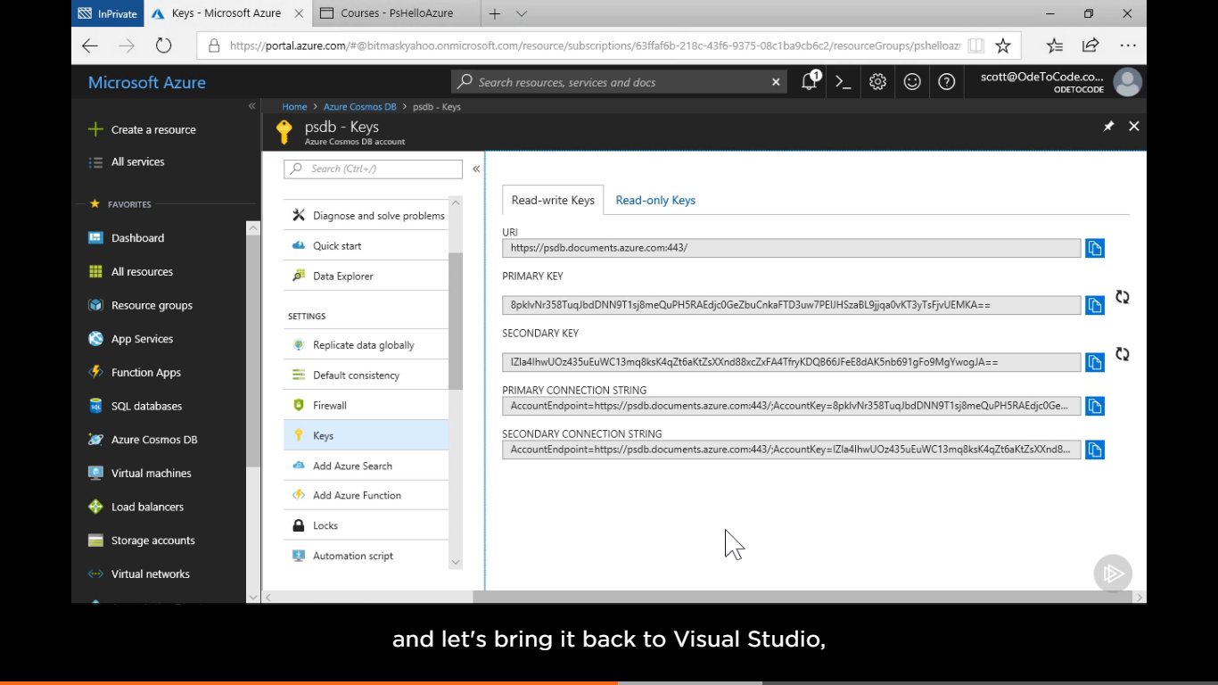 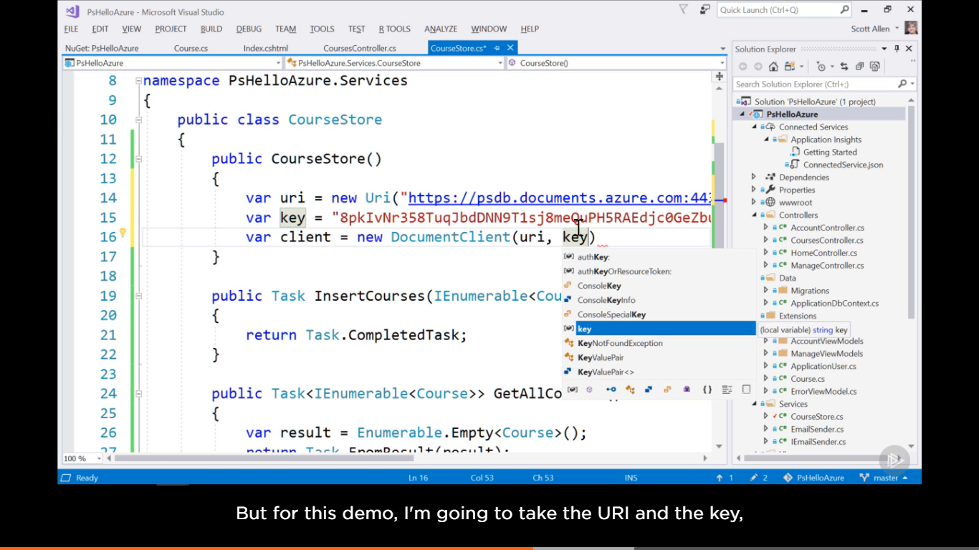 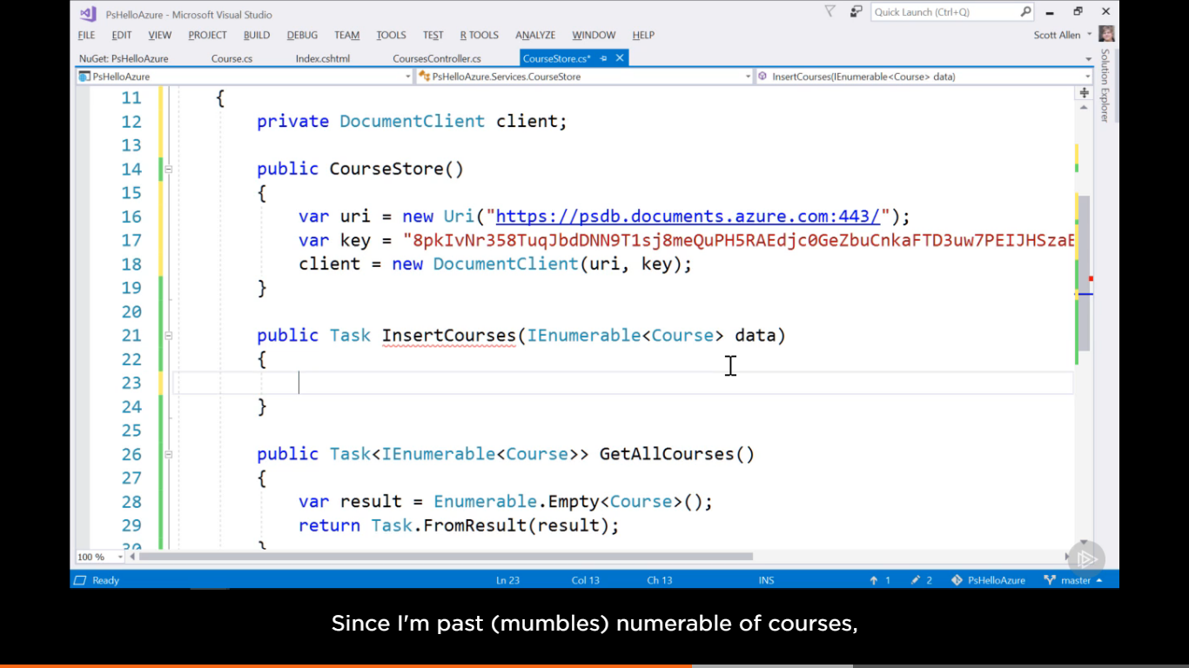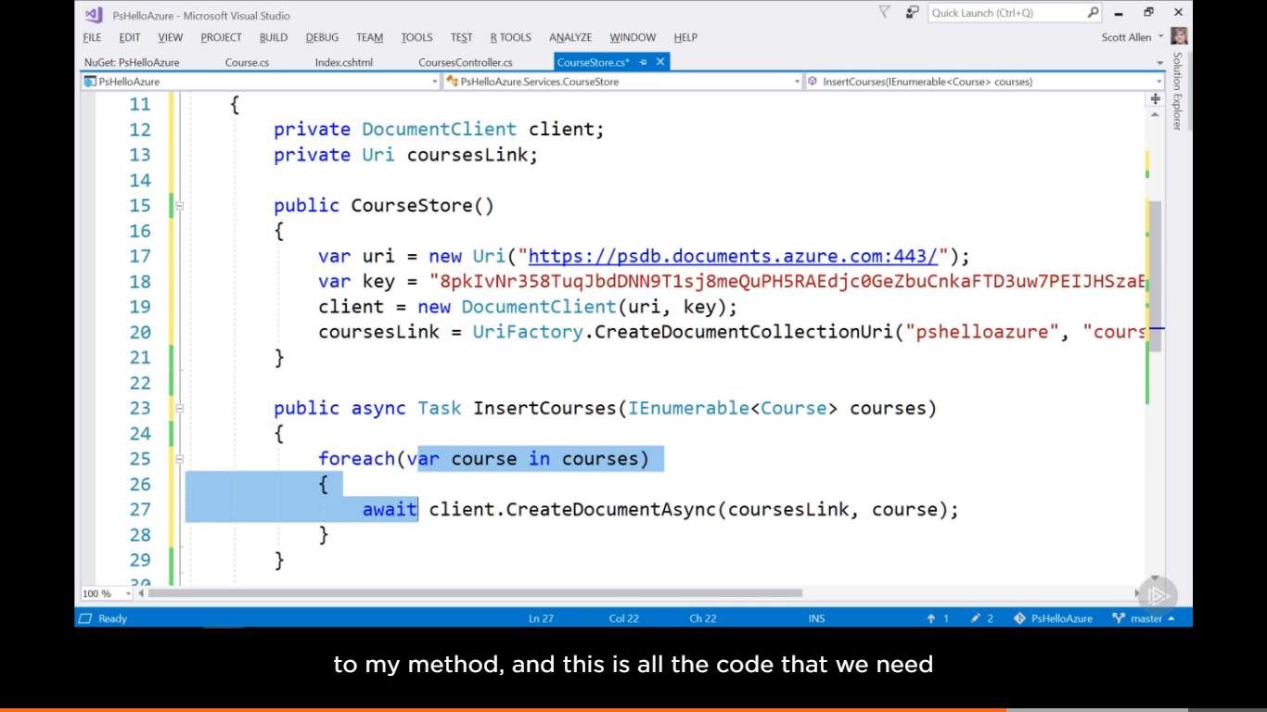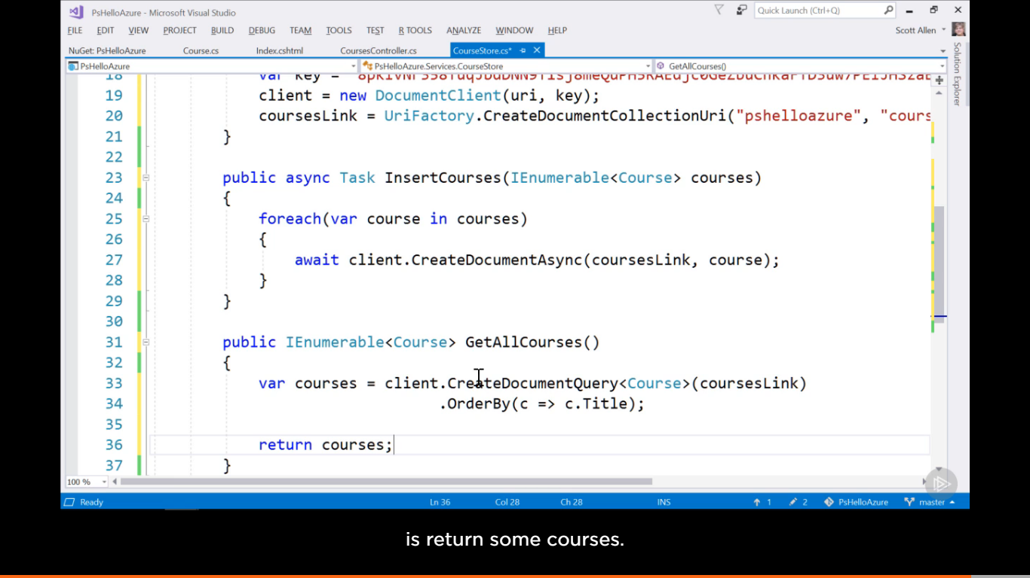

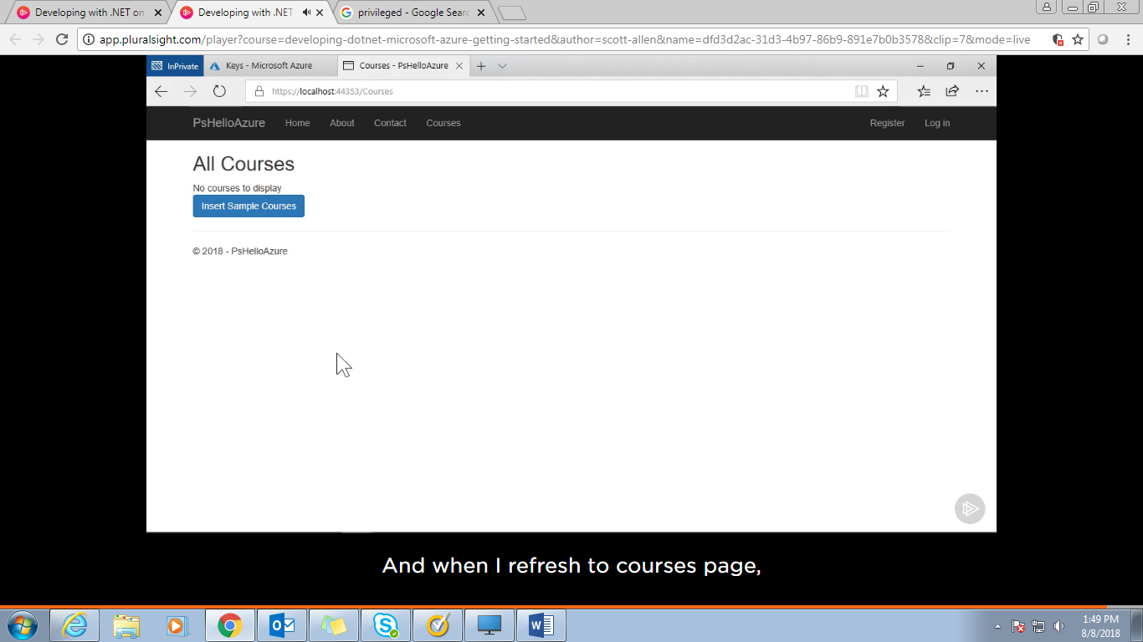

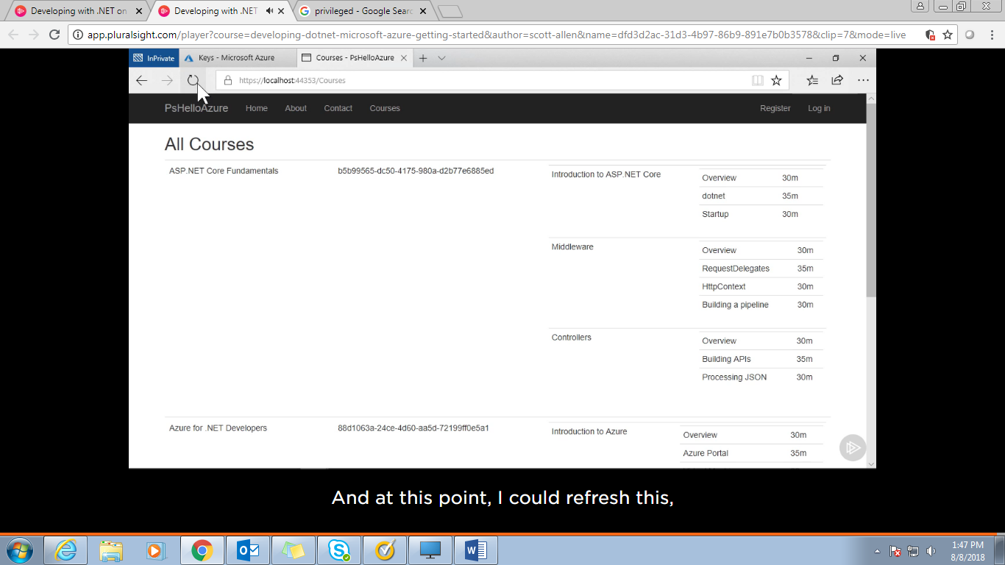

See the cource whem we refresh the page on browser

We can also see the stored cosmos database in Azure portal 